Russian weekly grain, end of week report, Nov 28-29, 2025
IKAR
Not for reproduction and redistribution. It is our policy that RWG and its parts are NOT distributed and NOT meant to ANY government body or agency. Thank you for your understanding and cooperation

Graphs of the week
The dynamics of ruble exchange rate
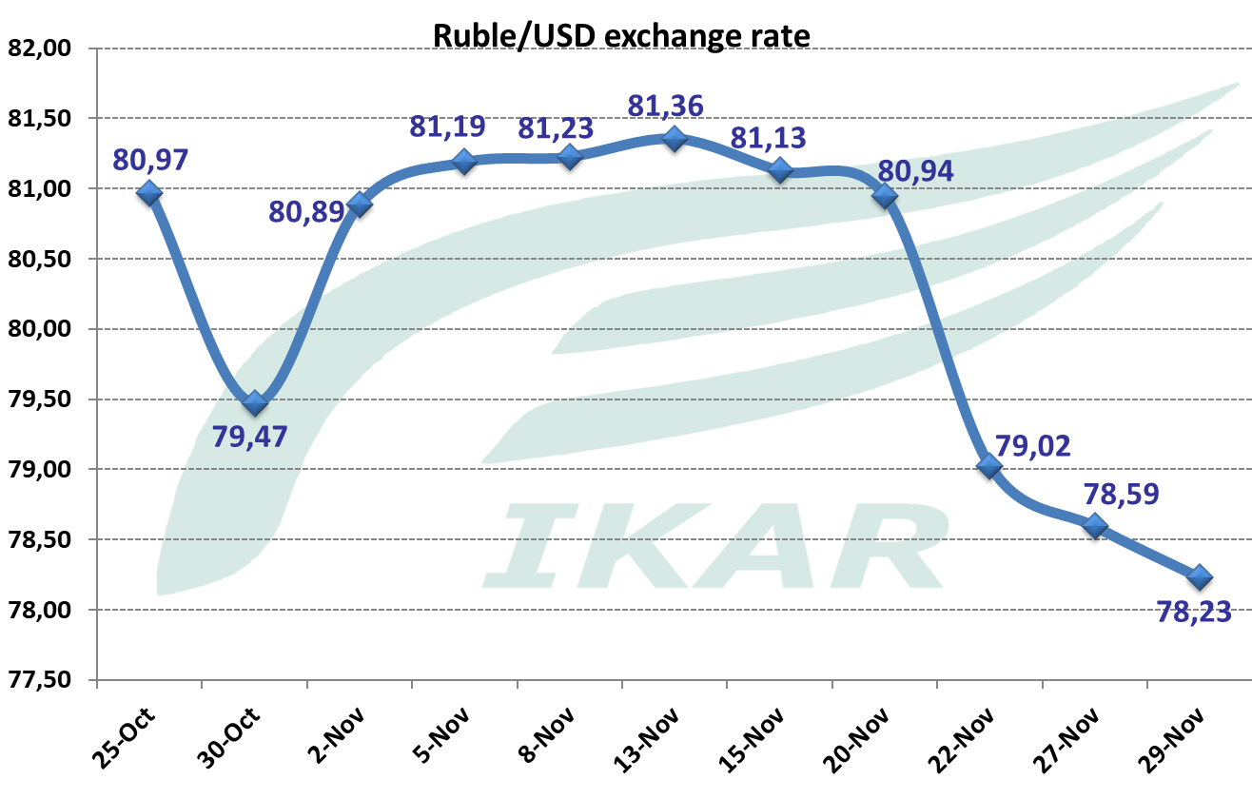 | 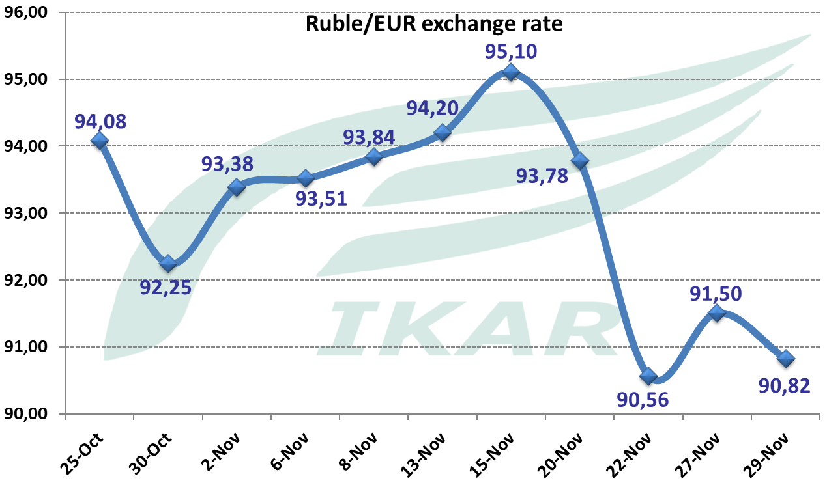
Again, obviously, short-term, any strengtheining of hopes for the peace deal, causes ruble strengthening,and vice versa, but to a lesser extent…

Hot topics and headlines

According to some experts, the Black Sea attack on two (although empty) crude oil vessels going to the Russian ports, may create new level of Black Sea navigation tension, risks and uncertainties…
***
November wheat export level continues to be seen at 5.3-5.5 mmt. Our December forecast is seen at about or slightly above 5 mmt. If so, taking in mind a. some potential current under-counting of export, b. relatively low December 2024 export figure, very roughly, one can come to about record high export of 27-27.5 mmt for Jul-Dec 2025/26 in comparison with 25.9 mmt in Jul-Dec 2024/25…
***
Azov Sea is in expectation of adverse wind from the middle of the upcoming week, which will blow out water from Don River and Taganrog Bay, and cause coasters navigation disruptions… Practice shows that it may last for quite a long time…
***
FOB Black Sea wheat prices remain in depression: our 12.5% close forward index is seen at $227 per ton. Amid strong ruble, and farmers resistance to sell, ceteris paribus, it continues to provide a negative margin...

One of those situations, when all three grain export duties are at zero or close to zero level…
***
Winter wheat situation remains satisfactory, although not w/o problems. As we predicted, the area shrinkage in comparison with previous season looks very modest, if any. Farmers don’t see an alternative, at least officially. Although we expected some area sagging in Central: according to official data, it does not happen… Most probably, bigger area shrinkage will take place on spring wheat, if winter normally survives (winter wheat kill resowing pattern substantially varies from one mega-region to another)…

The state of winter crops is generally satisfactory, although in the South summer drought-exposed spots still have too modest soil moisture levels. Then, due to very warm weather, in the South there emerge a threat of overgrowth…

Hot topic 1. Not to forget to publish our updated grain S&Ds

See also our weekly technical crops analysis, that provides even slightly higher production fgures.

Hot topic 2. Export activities. November wheat export level continues to be seen at 5.3-5.5 mmt. Again, it was a type of “quality nightmare” for exporters, as in the ocean of 12.5-16% protein, they could hardly find a “worsener”: wheat with protein below 12.5%, to make a final 12.5% blend. Wheat coming from the rest of Russia may be of lower protein, but with some additional inferiorities, such as bug damage, or low falling number, or whatever, or it’s problematic for “blunt” blend. Some November Black Sea lots contained 13.5%, or even 14% wheat.

Our December forecast is seen at about 5 mmt.

November 1-28 five Black Sea terminals and Novo container terminal export shipments are 2902 tmt, including 65 tmt of Kazakh lentils, and one handy barley (shipped from Taman), the rest is wheat. It’s in comparison with 2888 tmt a month ago. About 693 tmt of wheat was shipped from Novo to Iran. Visible line-ups remain high: 1620 tmt incomparison with 1852 tmt a week and 1585 tmt a week, two weeks ago.

Typically, November is featured with losing 8 working days due to bad weather. But, in terms of weather, this November sounds as very good: they lost only 3-4 days. However, there are other logistical issues.

November 1-28 Port Kavkaz shipments are 1213 tmt in comparison with 1474 tmt a month ago. It includes 160 tmt of barley, the rest is wheat, including 154 tmt to Sri Lanka. The visible line-ups are 601 tmt incl. one handy of barley to Turkiye, in comparison with 723 tmt of wheat a week, and 685 tmt two weeks ago.

November 1-28 Azov Sea shipments are 1127 in comparison with 1521 tmt a month ago. It tconsists predominantly from wheat to Port Kavkaz, and some fractions of corn, barley, and pea. The visible line-ups are 55 tmt in comparisonwith 71 tmt a week, and 89 tmt two week ago.

Caspian Sea shipments are seen now as 238 tmt, but we tend to believe it’s still under-counted. Now corn dominates she shipments, not barley.

Port Vysotsk shipments are 208 tmt of 11.5-12.5% wheat and barley. Morocco, Syria, Lybia, and Bangladesh are the destinations. Then we see a bunch of feed wheat vessels, some in combination with 11.5%...

Weekly all ports wheat shipments, as of Nov 28, tmt

Cumulative all ports wheat shipments, as of Nov 28, tmt

Weekly grains shipments from 5 Black Sea terminals as of Nov 28, tmt

Cumulative grains shipments from 5 Black Sea terminals, as of Nov 28, tmt

Weekly grains shipments from Azov Sea to Port Kavkaz anchor transshipment station, as of Nov 28, tmt

Cumulative grains shipments from Azov Sea to Port Kavkaz anchor transshipment station, as of Nov 28, tmt

Weekly wheat shipments to Turkiye, as of Nov 28, tmt

Cumulative wheat shipments to Turkiye, as of Nov 28, tmt

Five Black Sea terminals and Port Kavkaz visible weekly line-ups, tmt
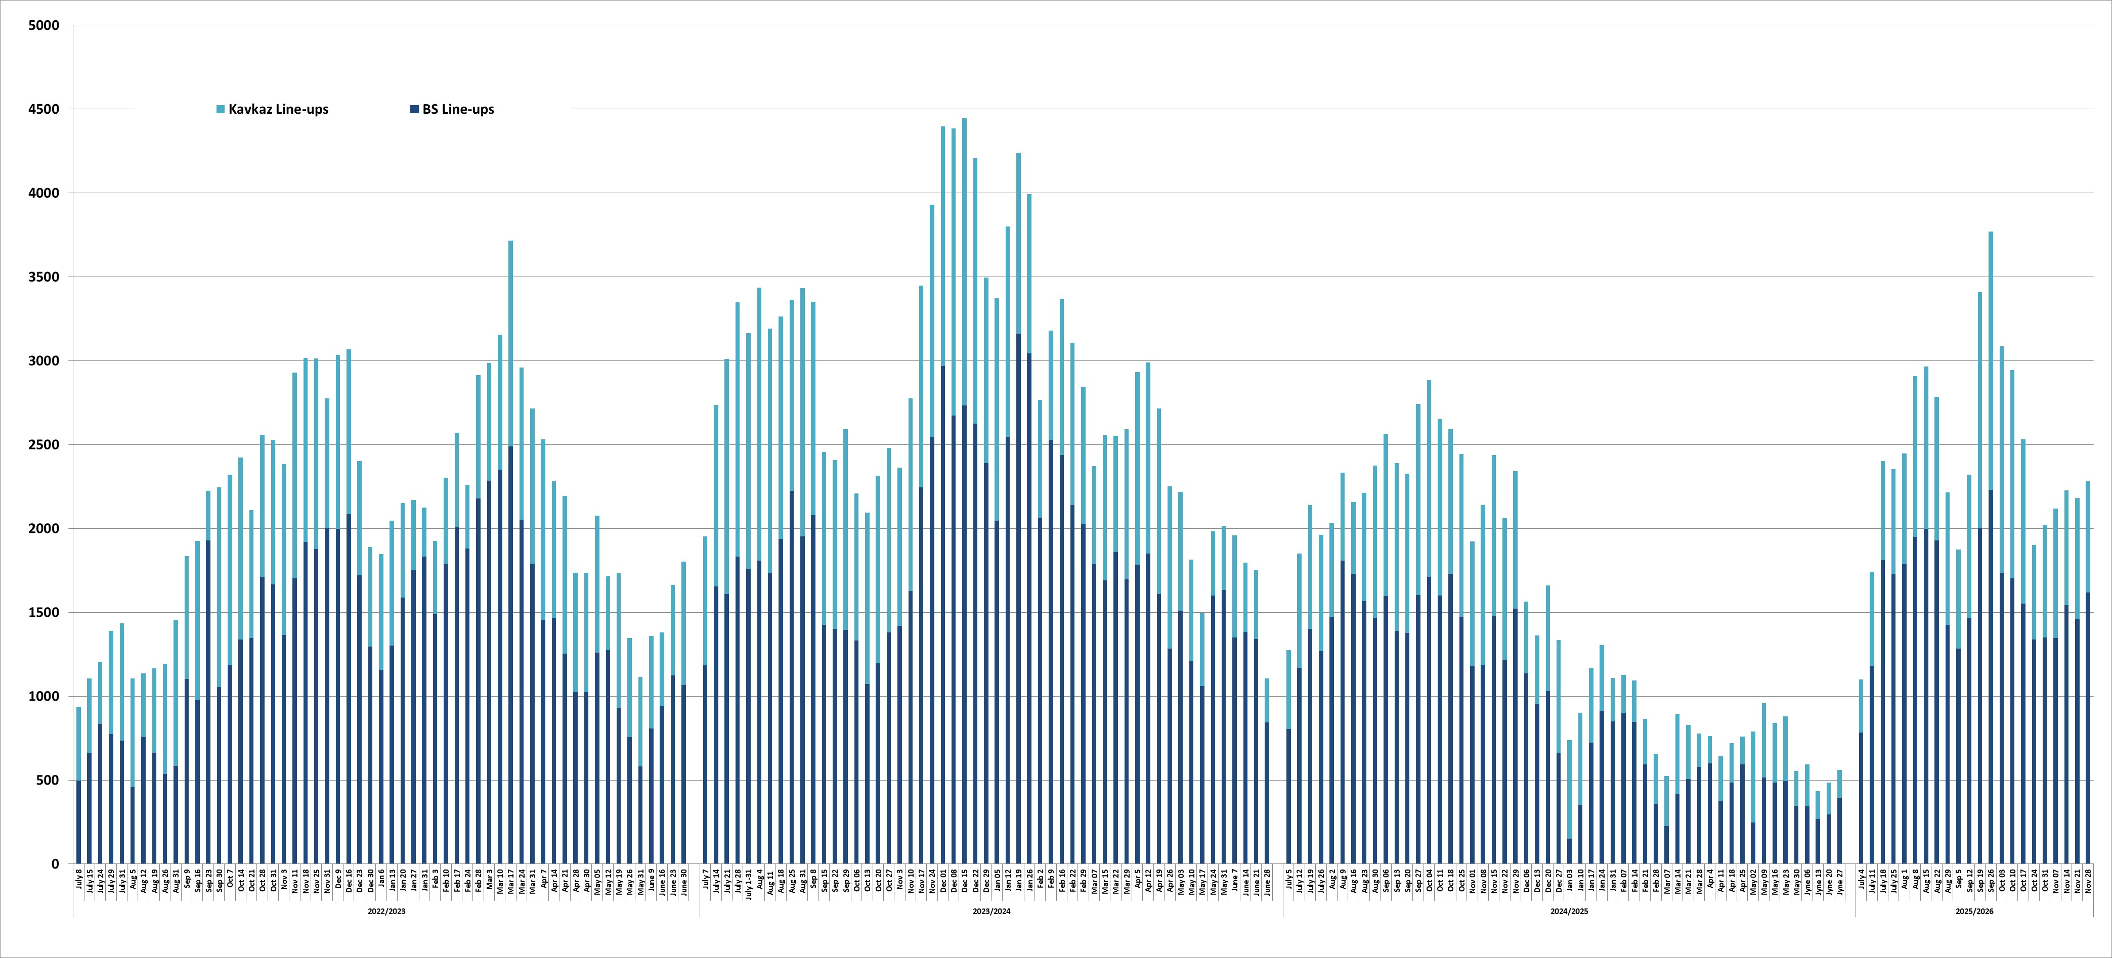

Rus grains export accrdng to ports and railway shipments data, tmt (subject to further upward revisions)*
 | Wheat |  |  |  |  | Barley |  |  |  |  | Corn |  |  |  |  | All grains+pulses
 | 2023/24 | 2024/25 | 2025/26 |  |  | 2023/24 | 2024/25 | 2025/26 |  |  | 2023/24 | 2024/25 | 2025/26 |  |  | 2023/24 | 2024/25 | 2025/26
 |  |  | Ports | In-land | Total |  |  | Ports | In-land | Total |  |  | Ports | In-land | Total |  |  | Ports | In-land | Total
July* | 4133 | 3425 | 1633 | 117 | 1750 | 1201 | 935 | 528 | 41 | 569 | 547 | 345 | 534 | 5 | 539 | 6166 | 4890 | 2735 | 202 | 2937
August | 5367 | 5490 | 4059 | 363 | 4422 | 1177 | 820 | 689 | 61 | 750 | 276 | 310 | 202 | 2 | 204 | 7162 | 6785 | 5148 | 465 | 5612
September | 5345 | 5840 | 4197 | 405 | 4602 | 999 | 745 | 657 | 76 | 733 | 281 | 300 | 114 | 2 | 117 | 7508 | 7182 | 5144 | 555 | 5699
October | 5049 | 5590 | 4993 | 478 | 5472 | 545 | 655 | 337 | 102 | 439 | 595 | 300 | 140 | 3 | 144 | 6729 | 7028 | 5735 | 675 | 6409
November 1-28 | 3397 | 5585 | 4498 | 220 | 4719 | 395 | 320 | 286 | 55 | 341 | 640 | 450 | 251 | 3 | 255 | 4792 | 6562 | 5118 | 322 | 5440
December | 3865 | 3185 | 0 | 0 | 0 | 363 | 475 | 0 | 0 | 0 | 591 | 430 | 0 | 0 | 0 | 5282 | 4408 | 0 | 0 | 0
January | 3938 | 3470 | 0 | 0 | 0 | 434 | 350 | 0 | 0 | 0 | 835 | 420 | 0 | 0 | 0 | 5590 | 4605 | 0 | 0 | 0
February | 4251 | 2410 | 0 | 0 | 0 | 456 | 295 | 0 | 0 | 0 | 843 | 235 | 0 | 0 | 0 | 5894 | 3184 | 0 | 0 | 0
March | 4646 | 2330 | 0 | 0 | 0 | 450 | 90 | 0 | 0 | 0 | 790 | 70 | 0 | 0 | 0 | 6304 | 2795 | 0 | 0 | 0
April | 4929 | 2250 | 0 | 0 | 0 | 977 | 25 | 0 | 0 | 0 | 651 | 70 | 0 | 0 | 0 | 6907 | 2588 | 0 | 0 | 0
May | 4660 | 2360 | 0 | 0 | 0 | 724 | 35 | 0 | 0 | 0 | 615 | 100 | 0 | 0 | 0 | 6343 | 2694 | 0 | 0 | 0
June | 4580 | 1430 | 0 | 0 | 0 | 591 | 30 | 0 | 0 | 0 | 514 | 90 | 0 | 0 | 0 | 5889 | 1717 | 0 | 0 | 0
Total | 54161 | 43365 | 19381 | 1584 | 20965 | 8312 | 4775 | 2497 | 335 | 2832 | 7178 | 3120 | 1242 | 16 | 1258 | 74566 | 54437 | 23880 | 2218 | 26097
November 1-28 | 2874 | 3751 | 4498 | 220 | 4719 | 319 | 361 | 286 | 55 | 341 | 590 | 347 | 251 | 3 | 255 | 4115 | 4622 | 5118 | 322 | 5440
01.07-28.11 | 22769 | 24096 | 19381 | 1584 | 20965 | 4242 | 3516 | 2497 | 335 | 2832 | 2288 | 1602 | 1242 | 16 | 1258 | 31679 | 30507 | 23880 | 2218 | 26097

*Nov 2025 – half a month railway export shipments

Hot topic 3. November 1-28 country export rating, tmt (w/o railway shipments data)
All grains | 5 393 |  | Wheat | 4 719 |  | Barley | 341 |  | Corn | 255
IRAN | 1006 |  | TURKIYE | 836 |  | IRAN | 98 |  | IRAN | 147
TURKIYE | 955 |  | IRAN | 759 |  | N/A | 72 |  | CHINA | 59
EGYPT | 690 |  | EGYPT | 690 |  | TURKIYE | 70 |  | TURKIYE | 45
N/A | 353 |  | BANGLADESH | 326 |  | CHINA | 52 |  | SKOREA | 4
BANGLADESH | 326 |  | N/A | 255 |  | LIBYA | 30
SUDAN | 193 |  | SUDAN | 193 |  | MOROCCO | 10
SRI LANKA | 181 |  | SRI LANKA | 181 |  | KAZAKHSTAN | 5
CHINA | 156 |  | ISRAEL | 152 |  | BELARUS | 3
ISRAEL | 152 |  | S ARABIA | 129 |  | IRAQ | 1
S ARABIA | 129 |  | YEMEN | 129 |  | AZERBAIJAN | 1
YEMEN | 129 |  | UAE | 105
LIBYA | 125 |  | LEBANON | 97
UAE | 105 |  | LIBYA | 95
LEBANON | 97 |  | MOROCCO | 82
MOROCCO | 92 |  | KENYA | 68
KENYA | 68 |  | ALGERIA | 60
ALGERIA | 60 |  | MOZAMBIQUE | 59
MOZAMBIQUE | 59 |  | IRAQ | 56
IRAQ | 58 |  | AZERBAIJAN | 54
AZERBAIJAN | 55 |  | TANZANIA | 53
TANZANIA | 53 |  | KAZAKHSTAN | 45
KAZAKHSTAN | 51 |  | SYRIA | 35
SYRIA | 35 |  | SOMALIA | 31
SOMALIA | 31 |  | CAMEROON | 30
CAMEROON | 30 |  | UGANDA | 29
UGANDA | 29 |  | MEXICO | 29
MEXICO | 29 |  | SIERRA LEONE | 28
SIERRA LEONE | 28 |  | NIGERIA | 23
NIGERIA | 23 |  | SAR | 19
S KOREA | 19 |  | CHINA | 15
SAR | 19 |  | ALBANIA | 12
ALBANIA | 12 |  | GEORGIA | 9
GEORGIA | 9 |  | UZBEKISTAN | 8
UZBEKISTAN | 8 |  | SWITZERLAND | 7
SWITZERLAND | 7 |  | KYRGYZSTAN | 6
KYRGYZSTAN | 6 |  | MONGOLIA | 3
MONGOLIA | 4 |  | TADJIKISTAN | 3
TADJIKISTAN | 3 |  | ETHIOPIA | 3
BELARUS | 3 |  | AFGHANISTAN | 2
ETHIOPIA | 3 |  | RWANDA | 2
AFGHANISTAN | 2 |  | ARMENIA | 1
RWANDA | 2
ARMENIA | 1

Hot topic 4. Ocean freight rates: in a new format

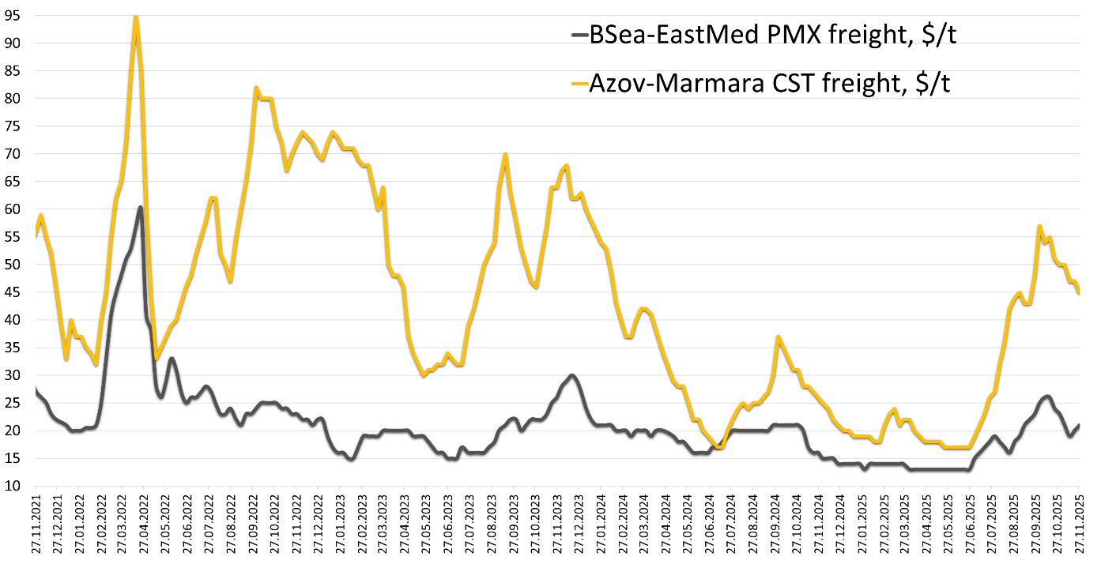

BSea-EastMed PMX freight, $/t
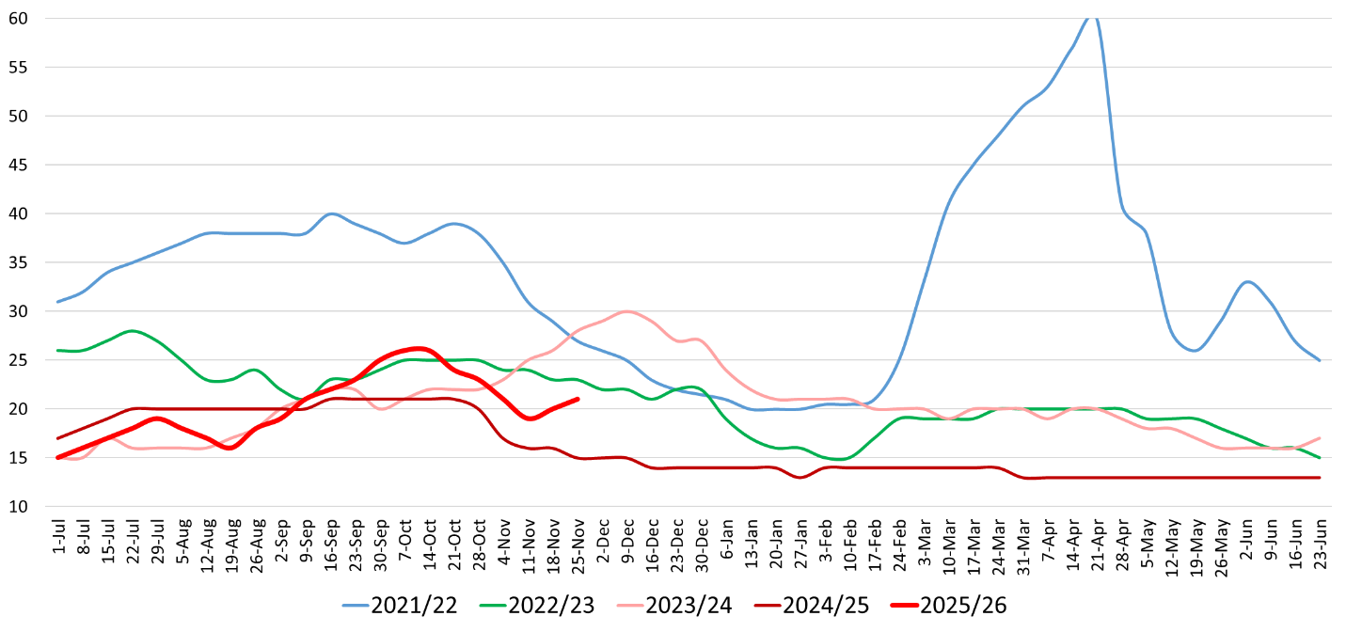

Azov-Marmara CST freight, $/t
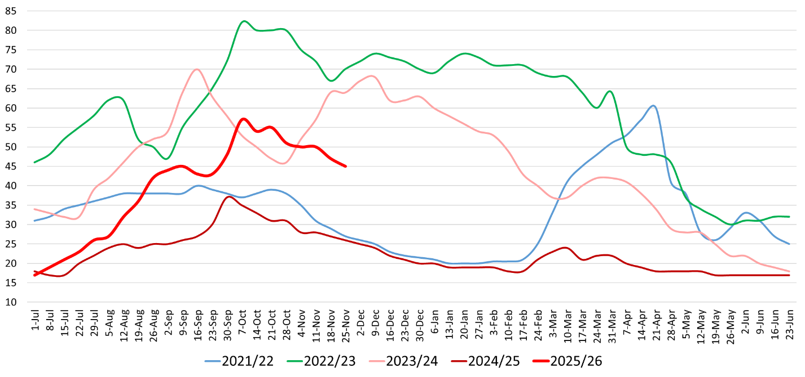

Hot topic 5. Key grain currencies to dollar (=100%)
Ruble continues to outperform all key grain currencies
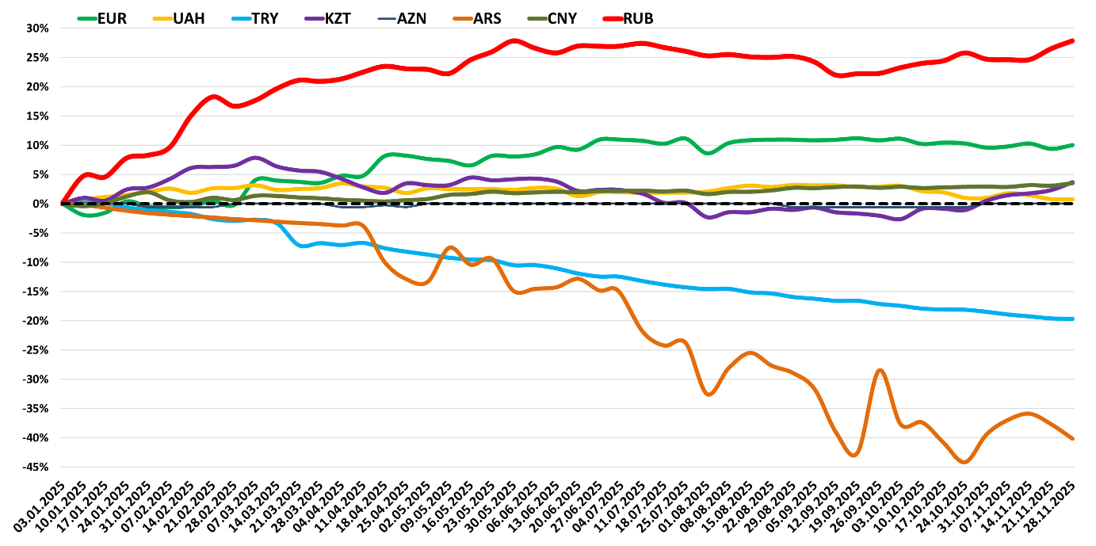

Hot topic 6. The dynamics of grain export duties.

The weekly dynamics of Moscow “exchange”’ 3 grains price indexes for determining export duties, $/ton
Contrary to spot market, the wheat price index on the Moscow Exchange is up from $227 to $228 per ton. Corn and barley indexes continue to vary,while the duties for both are zero.
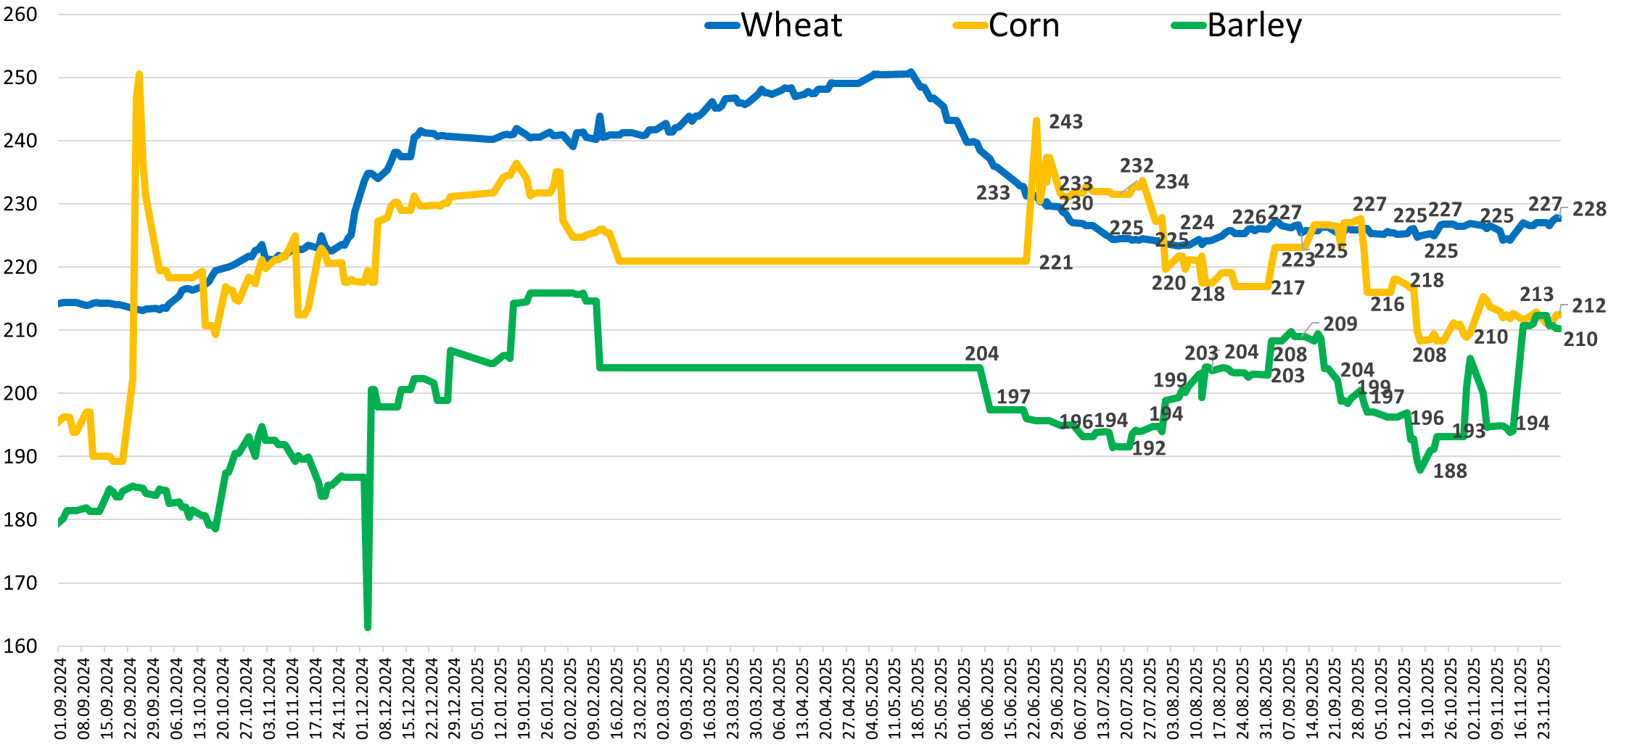

The dynamics of 3 weekly export duties, RUR/ton…
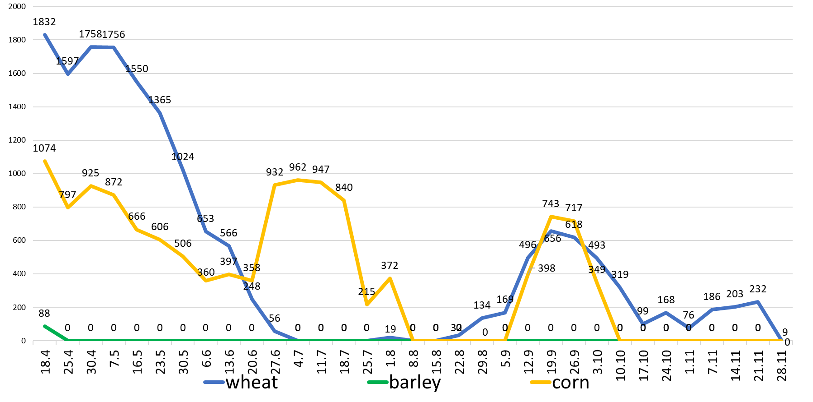

The dynamics of 3 weekly export duties, $/ton…
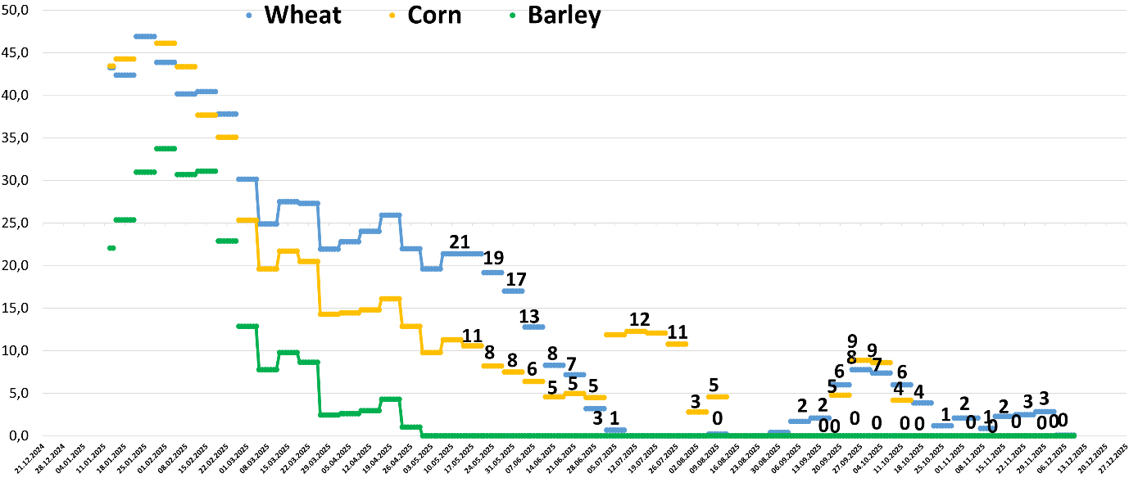

Hot topic 7. Weekly IKAR’ South Russian grain truck transportation index, rur/ton/km: stabilized…
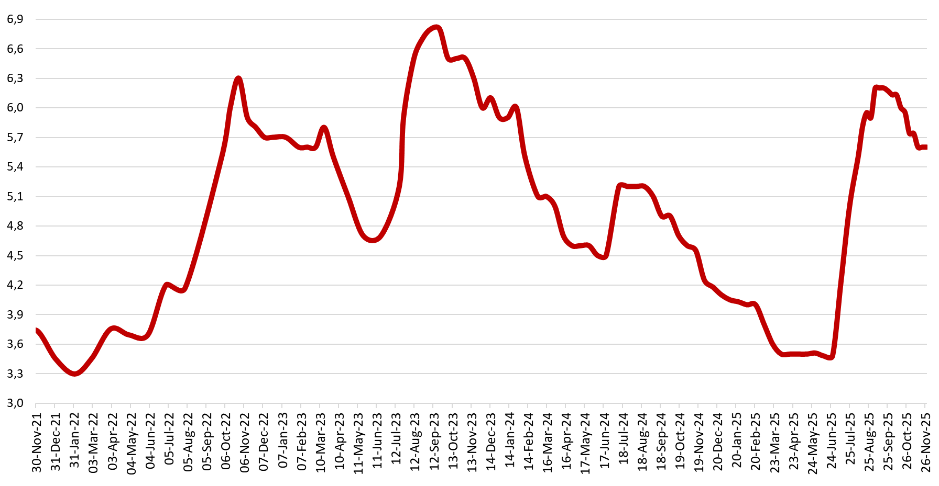

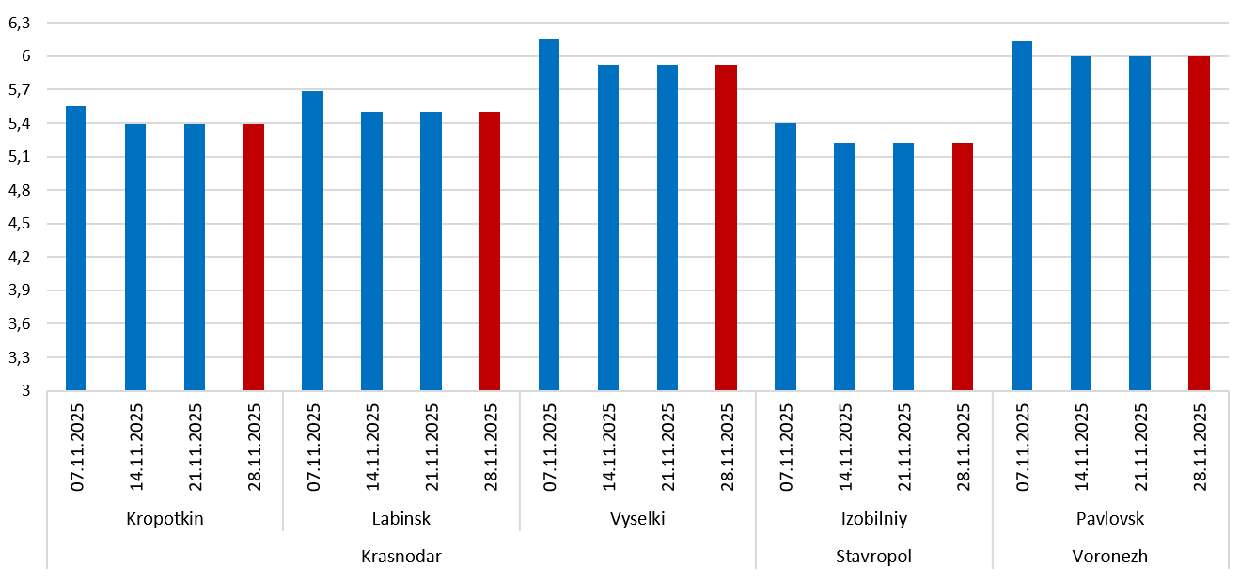

Date | Region | Indicative  Point | Destination  port | Distance, km | Price, RUB | Transportation cost,  RUB, 1mt/1km
07.11.2025 | Krasnodar | Vyselki | Novorossiysk | 250 | 1540 | 6,2
14.11.2025 | Krasnodar | Vyselki | Novorossiysk | 250 | 1480 | 5,9
21.11.2025 | Krasnodar | Vyselki | Novorossiysk | 250 | 1480 | 5,9
28.11.2025 | Krasnodar | Vyselki | Novorossiysk | 250 | 1480 | 5,9
07.11.2025 | Krasnodar | Labinsk | Novorossiysk | 320 | 1820 | 5,7
14.11.2025 | Krasnodar | Labinsk | Novorossiysk | 320 | 1760 | 5,5
21.11.2025 | Krasnodar | Labinsk | Novorossiysk | 320 | 1760 | 5,5
28.11.2025 | Krasnodar | Labinsk | Novorossiysk | 320 | 1760 | 5,5
07.11.2025 | Krasnodar | Kropotkin | Novorossiysk | 310 | 1720 | 5,5
14.11.2025 | Krasnodar | Kropotkin | Novorossiysk | 310 | 1670 | 5,4
21.11.2025 | Krasnodar | Kropotkin | Novorossiysk | 310 | 1670 | 5,4
28.11.2025 | Krasnodar | Kropotkin | Novorossiysk | 310 | 1670 | 5,4
07.11.2025 | Stavropol | Izobilniy | Novorossiysk | 400 | 2160 | 5,4
14.11.2025 | Stavropol | Izobilniy | Novorossiysk | 400 | 2090 | 5,2
21.11.2025 | Stavropol | Izobilniy | Novorossiysk | 400 | 2090 | 5,2
28.11.2025 | Stavropol | Izobilniy | Novorossiysk | 400 | 2090 | 5,2
07.11.2025 | Voronezh | Pavlovsk | Azov | 440 | 2700 | 6,1
14.11.2025 | Voronezh | Pavlovsk | Azov | 440 | 2640 | 6,0
21.11.2025 | Voronezh | Pavlovsk | Azov | 440 | 2640 | 6,0
28.11.2025 | Voronezh | Pavlovsk | Azov | 440 | 2640 | 6,0

Hot topic 8. Price situation. Regional export prices are further slightly lower: our FOB Black Sea 12.5% wheat price index is seen at $227 per ton, 11.5% is at $225 per ton …

After recent dropping, CPT export terminals prices vary depending on exporters operational needs: per truck deliveries, those who need big&quick volumes, need to pay RUR16200, while those who can wait, or need modest volumes, proclaim RUR15800-16000. So, our index is seen at RUR16100. For non-bound company RUR16100 provides $229 as Black Sea FOB cost equivalent (still w/o cost of finance), or still below the break-even…

Current railway delivery price is seen at RUR16100-16300 per ton of 12.5%, so if to take RUR16200, it provides $230-232 as FOB cost equivalent (although with 30-60 days delay).

On Azov Sea, reportedly, one can see some pre-New Year price decline, so that our index is seen now at RUR14850, although purchase prices continue to vary. For non-bound company RUR14500 provides about $194-195 as FOB cost equivalent, or close to break-even. FOB Port Kavkaz cost equivalent varies greatly, depending on Azov CPT purchase prices, and the arrangements with owners of coasters, but Azov – Port Kavkaz freight rates are seen lower nowadays – about $31 per ton, so Port Kavkaz cost equivalent provides about $225 per ton as Port Kavkaz FOB cost equivalent, w/o cost of finance and potential demurrage.

Across European part of Russia, one can observe stabilization of wheat prices, and even some signs of lowering.

Pre-export Black Sea barley prices are very problematic to discover, as the procurements shift from the South to Central and Volga regions.

Per corn Central Black Soil processors are paying RUR13900-14400 per ton, VAT inclusive. Price in Central stabilized at a comfortable level slightly above feed wheat prices.

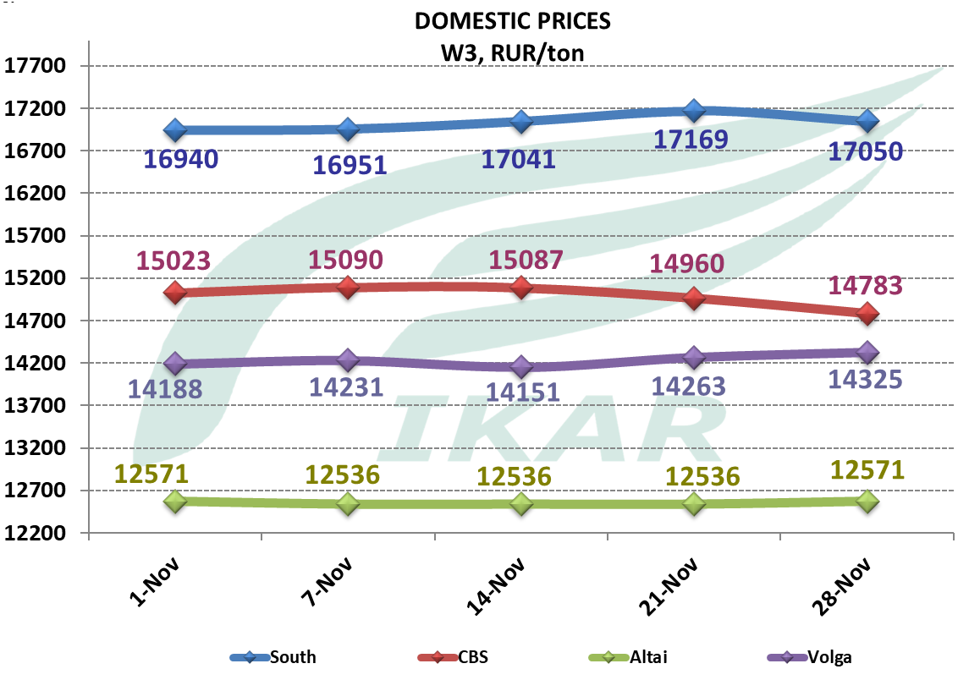
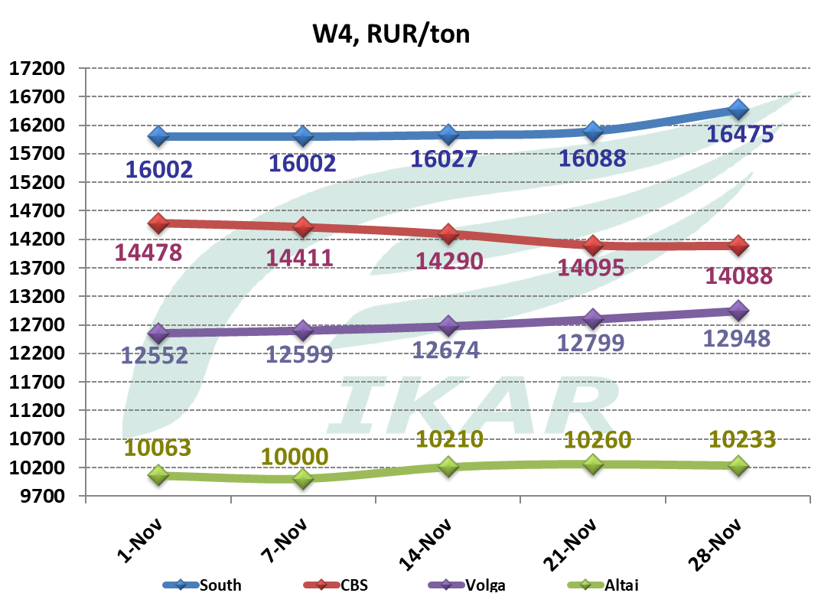
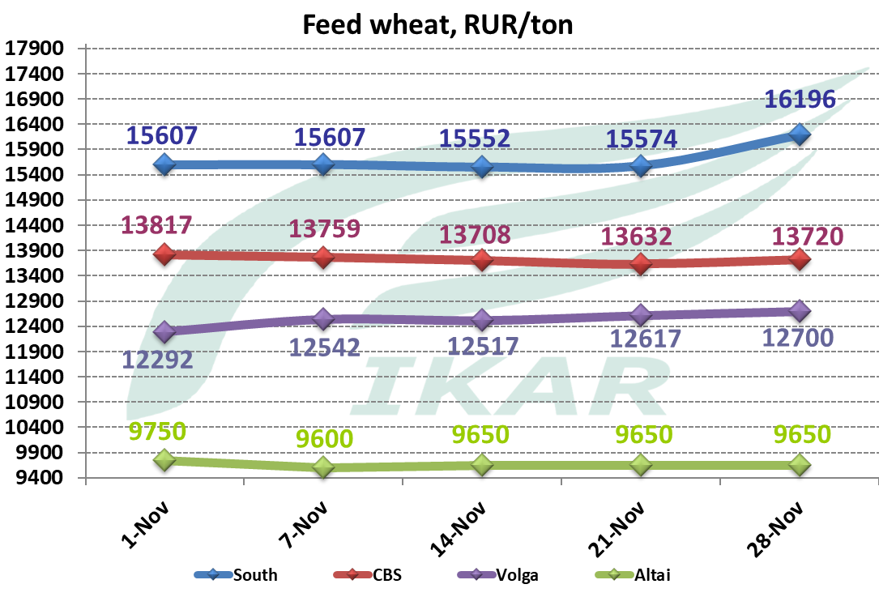
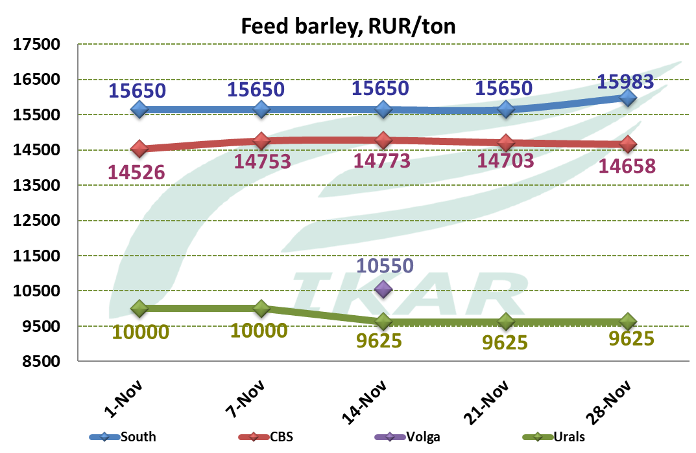
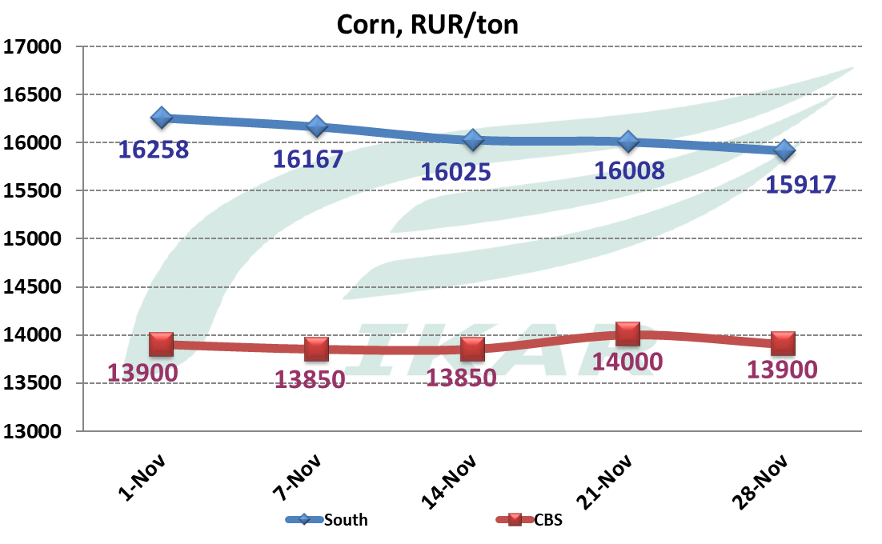

South Russian processors purchase price indexes, CPT processor, rur/ton
12.5% wheat
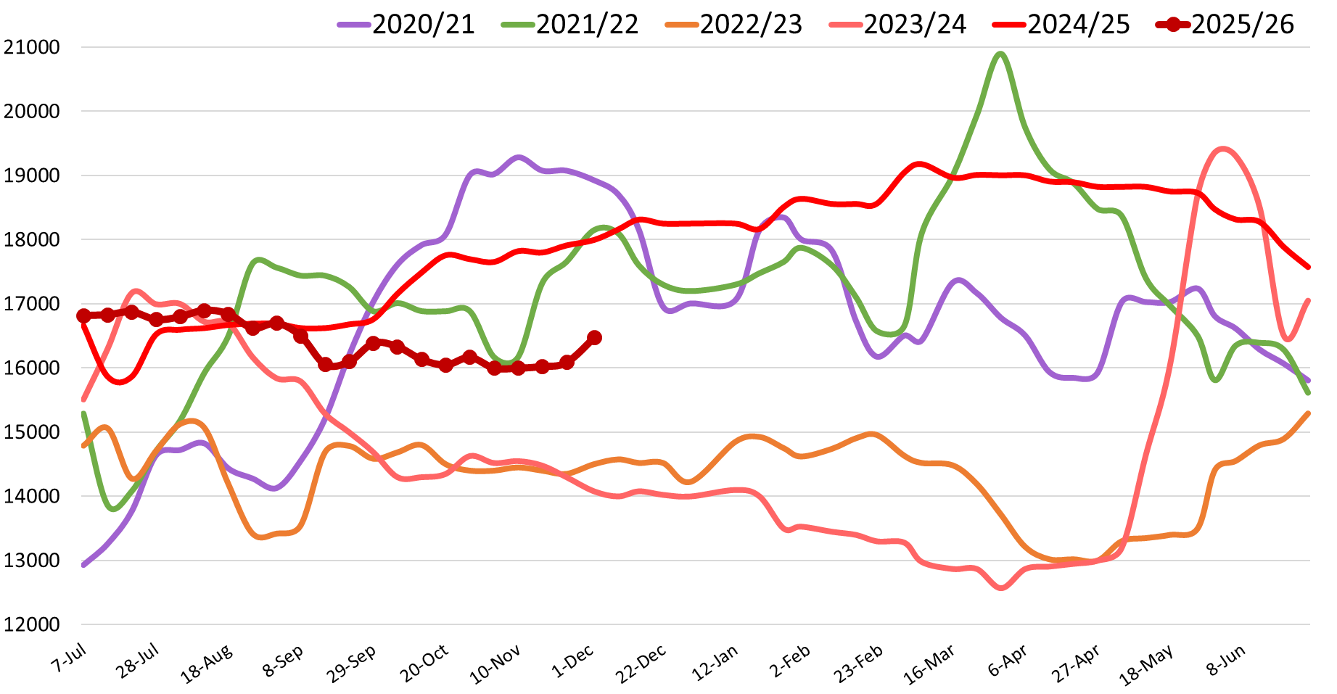

Barley
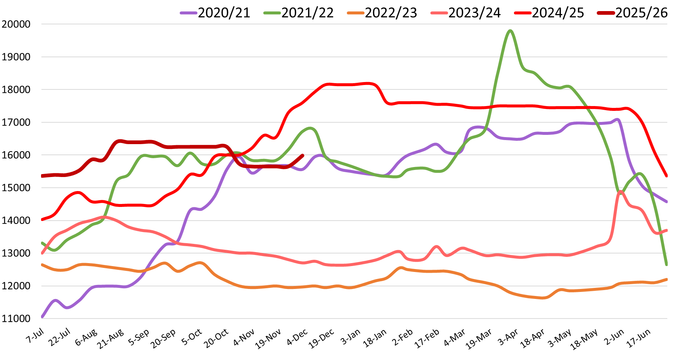

Corn
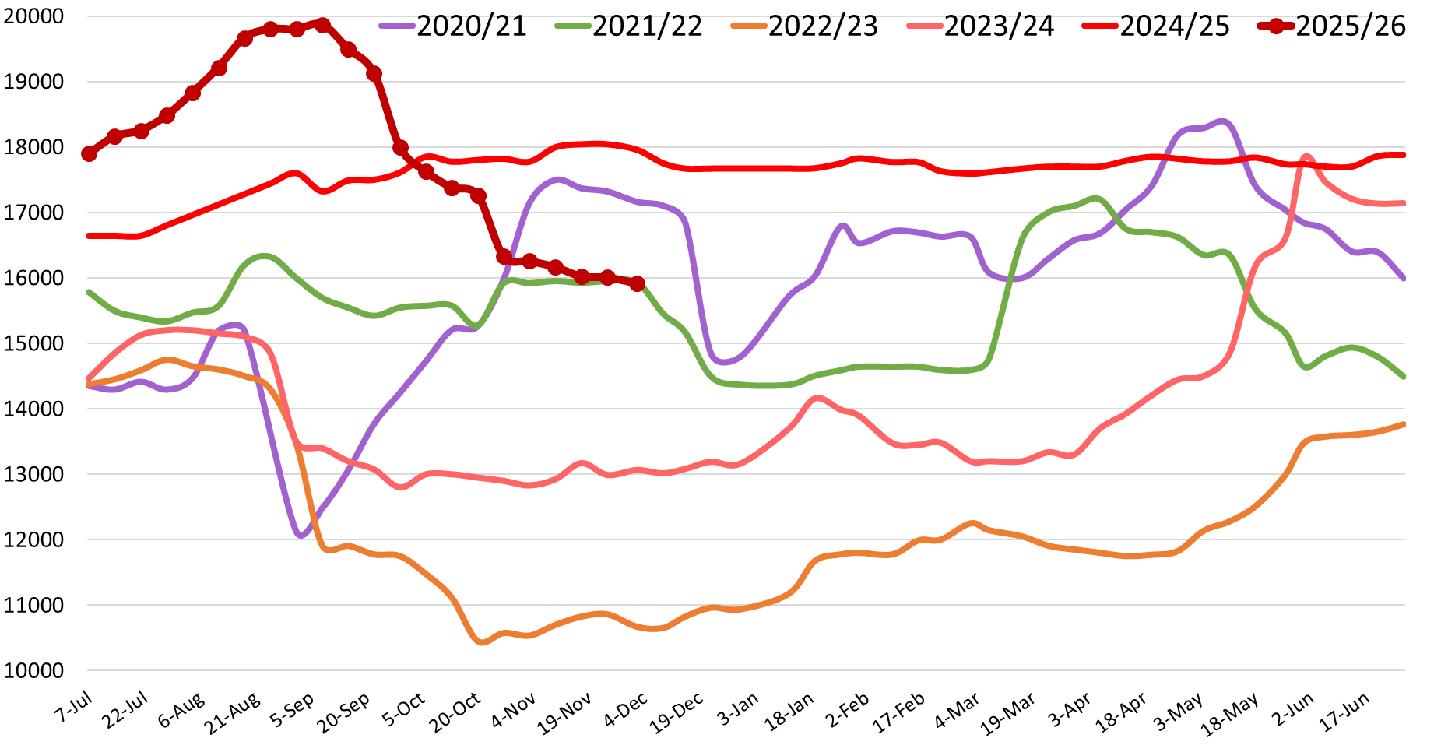

Central Black Soil processors purchase price indexes, rur/ton
12.5% wheat
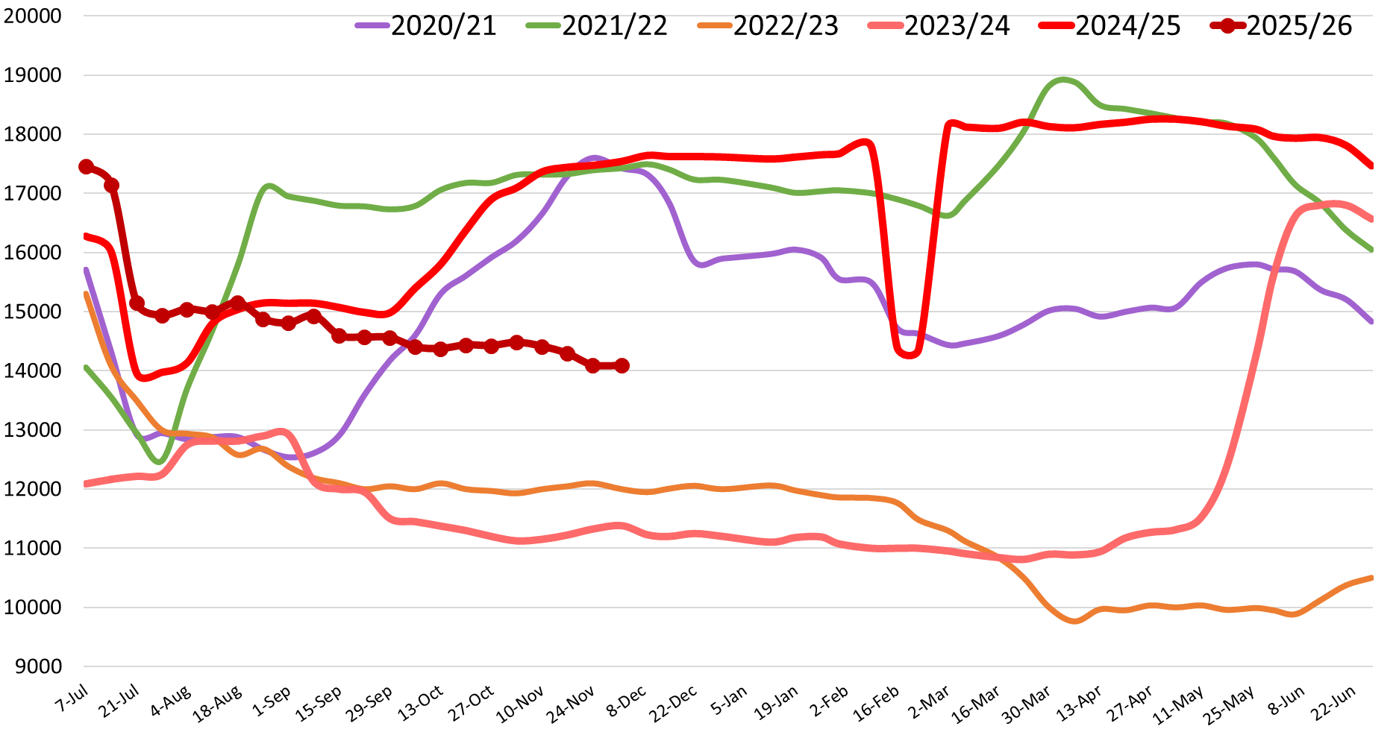

Barley
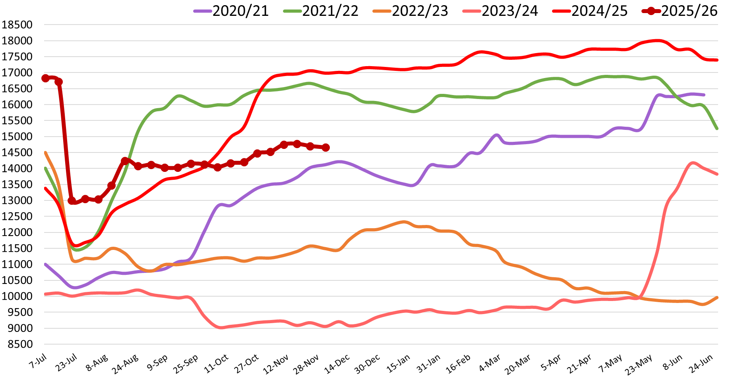

Corn
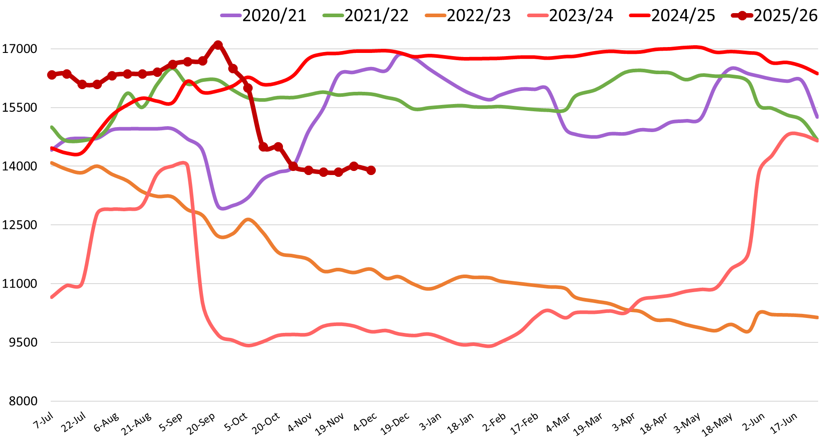

Hot topic 9. Our weekly technical crop counting

Hot topic 10. Winter grains and grasses sowing. As we predicted, winter sowing campaign finishes with very moderate area shrinkage in comparison with previous season. Of course, these are operational figures, which later may be slightly modified by Rosstat. One can observe slight area decline in Central and Volga, while area in the South ofRussia remains the same. From other sources we are aware that area under winter barley, and winter rapeseeds is up (although winter rapeseeds is not part of our data!), while area under rye is further down…

All Russia
South
N.Caucasus

Central

Volga

Addendum
Harvest progress as of November 28, 2025

 | Grains and pulses
Region | Area итог | Area harvested,Th.ha. |  | collected, TMT bunker weight |  | Yield, metric centner/ha
Region | Area итог | 2025 | 2024 | 2025 | 2024 | 2025 | 2024
Russian Federation | 45655 | 44 126 | 46 799 | 145 306 | 132 163 | 33 | 28
Rus Fed w/o new territories | 43796 | 42 284 | 45 058 | 141 501 | 128 105 | 33 | 28
Central Federal District | 7644 | 7 196 | 7 489 | 35 555 | 29 915 | 49 | 40
Belgorod | 584 | 549 | 586 | 3 126 | 2 323 | 57 | 40
Bryansk | 293 | 263 | 279 | 1 695 | 1 903 | 65 | 68
Vladimir | 96 | 91 | 85 | 321 | 226 | 35 | 27
Voronezh | 1480 | 1 424 | 1 280 | 6 026 | 3 858 | 42 | 30
Ivanovo | 57 | 55 | 62 | 152 | 132 | 28 | 21
Kaluga | 81 | 72 | 71 | 276 | 217 | 39 | 31
Kostroma | 23 | 20 | 25 | 48 | 43 | 24 | 17
Kursk | 765 | 686 | 838 | 3 927 | 4 217 | 57 | 50
Lipetsk | 779 | 751 | 769 | 4 038 | 3 171 | 54 | 41
Moscow Region | 171 | 163 | 170 | 613 | 527 | 38 | 31
Orel | 701 | 646 | 761 | 3 391 | 3 681 | 53 | 48
Ryazan | 713 | 691 | 709 | 3 111 | 2 766 | 45 | 39
Smolensk | 152 | 136 | 142 | 401 | 352 | 30 | 25
Tambov | 1047 | 986 | 1 042 | 5 574 | 4 021 | 57 | 39
Tver | 69 | 69 | 69 | 193 | 167 | 28 | 24
Tula | 593 | 560 | 565 | 2 550 | 2 225 | 46 | 39
Yaroslavl | 41 | 35 | 38 | 112 | 87 | 32 | 23
North-West Federal District | 302 | 278 | 298 | 1 274 | 1 256 | 46 | 42
Vologda | 84 | 80 | 85 | 204 | 201 | 26 | 24
Kaliningrad | 133 | 120 | 126 | 810 | 763 | 68 | 61
Leningrad Region | 40 | 39 | 41 | 138 | 147 | 35 | 36
Novgorod | 10 | 7 | 10 | 16 | 21 | 21 | 22
Pskov | 36 | 31 | 36 | 106 | 123 | 34 | 34
South Federal District | 9160 | 8 780 | 9 005 | 28 381 | 32 296 | 32 | 36
Adyghe Republic | 129 | 125 | 129 | 682 | 605 | 55 | 47
Kalmuck Republic | 283 | 271 | 271 | 838 | 744 | 31 | 28
the Crimea | 522 | 522 | 570 | 1 180 | 1 546 | 23 | 27
Krasnodar | 2483 | 2 408 | 2 451 | 11 157 | 13 872 | 46 | 57
Astrakhan | 22 | 17 | 18 | 59 | 66 | 36 | 37
Volgograd | 2174 | 2 123 | 2 075 | 5 872 | 3 976 | 28 | 19
Rostov-on-Don | 3548 | 3 314 | 3 491 | 8 595 | 11 486 | 26 | 33
North Caucasus District | 3227 | 3 143 | 3 268 | 13 720 | 11 284 | 44 | 35
Republic of Dagestan | 145 | 138 | 158 | 429 | 475 | 31 | 30
Ingush Republic | 43 | 37 | 20 | 134 | 52 | 36 | 26
Kabardian-Balkar Republic | 202 | 202 | 207 | 1 200 | 1 072 | 60 | 52
Karachaevo-Cherkessya Republic | 86 | 77 | 79 | 441 | 274 | 57 | 35
Republic of Horth Ossetia-Alania | 132 | 124 | 131 | 492 | 542 | 40 | 41
Chechen Republic | 183 | 182 | 190 | 537 | 547 | 30 | 29
Stavropol | 2435 | 2 383 | 2 484 | 10 488 | 8 322 | 44 | 34
Volga Federal District | 12296 | 12 085 | 12 819 | 34 570 | 28 652 | 29 | 22
Bashkir Republic | 1379 | 1 379 | 1 442 | 3 800 | 3 260 | 28 | 23
Mari El Republic | 140 | 138 | 135 | 418 | 307 | 30 | 23
Republic of Mordovia | 487 | 482 | 464 | 1 971 | 1 431 | 41 | 31
Republic of Tatarstan | 1286 | 1 266 | 1 377 | 4 896 | 4 026 | 39 | 29
Udmurt Republic | 323 | 283 | 340 | 860 | 734 | 30 | 22
Chuvash Republic | 281 | 277 | 276 | 1 013 | 780 | 37 | 28
Perm | 176 | 171 | 205 | 372 | 380 | 22 | 19
Kirov | 304 | 274 | 290 | 753 | 640 | 28 | 22
Nizhny Novgorod | 618 | 611 | 613 | 1 973 | 1 604 | 32 | 26
Orenburg | 2389 | 2 389 | 2 558 | 4 159 | 4 050 | 17 | 16
Penza | 847 | 839 | 875 | 3 472 | 2 673 | 41 | 31
Samara | 1195 | 1 161 | 1 219 | 3 262 | 2 628 | 28 | 22
Saratov | 2247 | 2 200 | 2 349 | 5 397 | 4 285 | 25 | 18
Ulianovsk | 624 | 617 | 678 | 2 225 | 1 853 | 36 | 27
Ural Federal District | 2960 | 2 933 | 3 337 | 7 162 | 6 585 | 24 | 20
Kurgan | 840 | 839 | 980 | 2 081 | 1 963 | 25 | 20
Sverdlovsk | 313 | 289 | 310 | 768 | 807 | 27 | 26
Tyumen | 633 | 631 | 694 | 1 867 | 1 579 | 30 | 23
Chelyabinsk | 1175 | 1 175 | 1 353 | 2 446 | 2 237 | 21 | 17
Siberian Federal District | 7707 | 7 445 | 8 413 | 19 273 | 16 838 | 26 | 20
Altai Republic | 6 | 5 | 6 | 10 | 8 | 18 | 15
Republic of Tuva | 8 | 1 | 5 | 2 | 4 | 11 | 8
Khakass Republic | 78 | 76 | 86 | 162 | 135 | 22 | 16
Altai | 2753 | 2 688 | 3 098 | 6 462 | 5 828 | 24 | 19
Krasnoyarsk | 786 | 771 | 844 | 2 620 | 2 158 | 34 | 26
Irkutsk | 323 | 310 | 341 | 655 | 635 | 21 | 19
Kemerovo | 531 | 515 | 536 | 1 654 | 1 235 | 32 | 23
Novosibirsk | 1200 | 1 190 | 1 354 | 3 259 | 2 560 | 27 | 19
Omsk | 1877 | 1 744 | 1 999 | 4 057 | 3 963 | 23 | 20
Tomsk | 145 | 144 | 145 | 393 | 311 | 27 | 21
Far Eastern Federal District | 500 | 424 | 429 | 1 565 | 1 281 | 37 | 30
Republic of Buryatia | 67 | 44 | 67 | 46 | 105 | 10 | 16
Yakytia | 12 | 11 | 10 | 15 | 10 | 14 | 10
Transbaikal Territory | 81 | 70 | 70 | 126 | 97 | 18 | 14
Primorye Territory | 147 | 112 | 87 | 743 | 389 | 66 | 45
Khabarovsk Territory | 7 | 6 | 7 | 11 | 16 | 17 | 22
Amur Region | 174 | 169 | 174 | 547 | 590 | 32 | 34
Kamchatka Region | 1 | 1 | 1 | 0 | 1 | 7 | 18
Jewish Autonomous Region | 11 | 11 | 12 | 78 | 73 | 69 | 59
Total for new subjects | 1859 | 1 843 | 1 741 | 3 805 | 4 058 | 21 | 23
Donetsk | 245 | 242 | 236 | 417 | 497 | 17 | 21
Luhansk | 334 | 353 | 302 | 886 | 551 | 25 | 18
Zaporozhye | 667 | 615 | 627 | 1 261 | 1 702 | 21 | 27
Kherson | 613 | 633 | 577 | 1 240 | 1 308 | 20 | 23

 | WHEAT
Region | Area (расчет) | Area harvested,Th.ha. |  | collected, TMT bunker weight |  | Yield, metric centner/ha
Region | Area (расчет) | 2025 | 2024 | 2025 | 2024 | 2025 | 2024
Russian Federation | 28308 | 27833 | 29495 | 94800 | 87760 | 34 | 30
Rus Fed w/o new territories | 26904 | 26463 | 28191 | 91765 | 84478 | 35 | 30
Central Federal District | 4586 | 4538 | 4508 | 21958 | 17319 | 48 | 38
Belgorod | 408 | 396 | 391 | 2036 | 1489 | 51 | 38
Bryansk | 125 | 121 | 127 | 656 | 562 | 54 | 44
Vladimir | 53 | 50 | 46 | 192 | 122 | 39 | 27
Voronezh | 845 | 844 | 676 | 3563 | 1921 | 42 | 28
Ivanovo | 25 | 24 | 23 | 76 | 55 | 32 | 24
Kaluga | 47 | 46 | 46 | 195 | 148 | 43 | 32
Kostroma | ... | 7 | 7 | 17 | 13 | 26 | 20
Kursk | 464 | 459 | 529 | 2460 | 2494 | 54 | 47
Lipetsk | 527 | 526 | 507 | 2713 | 2040 | 52 | 40
Moscow Region | 114 | 113 | 121 | 460 | 385 | 41 | 32
Orel | 434 | 430 | 466 | 2328 | 2220 | 54 | 48
Ryazan | 442 | 434 | 459 | 2069 | 1849 | 48 | 40
Smolensk | 67 | 65 | 72 | 237 | 191 | 36 | 27
Tambov | 591 | 591 | 607 | 2958 | 2117 | 50 | 35
Tver | 45 | 44 | 37 | 151 | 116 | 34 | 31
Tula | 379 | 376 | 382 | 1800 | 1564 | 48 | 41
Yaroslavl | 13 | 13 | 13 | 48 | 35 | 38 | 27
North-West Federal District | 151 | 146 | 147 | 798 | 680 | 55 | 46
Vologda | 16 | 16 | 15 | 43 | 38 | 28 | 25
Kaliningrad | 89 | 87 | 83 | 602 | 473 | 69 | 57
Leningrad Region | 14 | 14 | 15 | 48 | 55 | 35 | 36
Novgorod | 5 | 4 | 4 | 10 | 9 | 24 | 24
Pskov | 27 | 26 | 29 | 96 | 104 | 37 | 36
South Federal District | 6693 | 6528 | 6620 | 22135 | 25587 | 34 | 39
Adyghe Republic | 91 | 88 | 91 | 542 | 455 | 61 | 50
Kalmuck Republic | 240 | 235 | 241 | 761 | 667 | 32 | 28
the Crimea | 306 | 306 | 317 | 784 | 977 | 26 | 31
Krasnodar | 1632 | 1632 | 1588 | 7865 | 10283 | 48 | 65
Astrakhan | ... | 4 | 5 | 14 | 16 | 33 | 34
Volgograd | 1586 | 1572 | 1545 | 4666 | 3043 | 30 | 20
Rostov-on-Don | 2832 | 2691 | 2833 | 7502 | 10145 | 28 | 36
North Caucasus District | 2043 | 2037 | 2101 | 9254 | 7470 | 45 | 36
Republic of Dagestan | 61 | 61 | 74 | 167 | 178 | 27 | 24
Ingush Republic | 17 | 17 | 11 | 64 | 34 | 38 | 30
Kabardian-Balkar Republic | 56 | 55 | 56 | 269 | 210 | 49 | 37
Karachaevo-Cherkessya Republic | 20 | 17 | 15 | 93 | 87 | 57 | 60
Republic of Horth Ossetia-Alania | 33 | 32 | 33 | 124 | 99 | 38 | 30
Chechen Republic | 93 | 93 | 111 | 322 | 333 | 35 | 30
Stavropol | 1762 | 1762 | 1802 | 8216 | 6531 | 47 | 36
Volga Federal District | 7143 | 7074 | 7555 | 21481 | 17940 | 30 | 24
Bashkir Republic | 762 | 760 | 799 | 2253 | 1915 | 30 | 24
Mari El Republic | 56 | 55 | 54 | 184 | 138 | 33 | 26
Republic of Mordovia | 257 | 256 | 235 | 1004 | 747 | 39 | 32
Republic of Tatarstan | 774 | 772 | 797 | 3041 | 2309 | 39 | 29
Udmurt Republic | 115 | 81 | 119 | 246 | 283 | 30 | 24
Chuvash Republic | 151 | 149 | 161 | 573 | 481 | 38 | 30
Perm | 77 | 74 | 86 | 154 | 163 | 21 | 19
Kirov | 89 | 80 | 82 | 225 | 182 | 28 | 22
Nizhny Novgorod | 372 | 370 | 360 | 1268 | 1023 | 34 | 28
Orenburg | 1586 | 1586 | 1697 | 3082 | 2915 | 19 | 17
Penza | 611 | 608 | 639 | 2465 | 2007 | 41 | 31
Samara | 671 | 660 | 694 | 2187 | 1768 | 33 | 26
Saratov | 1223 | 1223 | 1396 | 3309 | 2740 | 27 | 20
Ulianovsk | 401 | 400 | 437 | 1490 | 1270 | 37 | 29
Ural Federal District | 1847 | 1830 | 2175 | 4573 | 4469 | 25 | 21
Kurgan | 574 | 566 | 714 | 1403 | 1459 | 25 | 20
Sverdlovsk | 145 | 136 | 147 | 376 | 432 | 28 | 29
Tyumen | 391 | 390 | 435 | 1170 | 1041 | 30 | 24
Chelyabinsk | 738 | 738 | 879 | 1624 | 1537 | 22 | 18
Siberian Federal District | 4303 | 4184 | 4939 | 11299 | 10698 | 27 | 22
Republic of Tuva | 3 | 1 | 2 | 1 | 2 | 11 | 9
Khakass Republic | 39 | 38 | 48 | 95 | 80 | 25 | 17
Altai | 1434 | 1418 | 1627 | 3618 | 3625 | 26 | 22
Krasnoyarsk | 441 | 433 | 537 | 1533 | 1369 | 35 | 26
Irkutsk | 161 | 155 | 179 | 324 | 327 | 21 | 18
Kemerovo | 252 | 249 | 267 | 873 | 674 | 35 | 25
Novosibirsk | 677 | 677 | 824 | 1904 | 1634 | 28 | 20
Omsk | 1213 | 1131 | 1356 | 2709 | 2767 | 24 | 20
Tomsk | 84 | 84 | 100 | 243 | 220 | 29 | 22
Far Eastern Federal District | 139 | 126 | 146 | 267 | 316 | 21 | 22
Republic of Buryatia | 33 | 23 | 32 | 23 | 50 | 10 | 16
Yakytia | 2 | 2 | 2 | 2 | 1 | 12 | 9
Transbaikal Territory | 33 | 31 | 27 | 53 | 39 | 17 | 14
Primorye Territory | 4 | 3 | 4 | 6 | 5 | 18 | 13
Khabarovsk Territory | 1 | 1 | 1 | 1 | 2 | 19 | 17
Amur Region | 66 | 65 | 79 | 180 | 216 | 28 | 27
Jewish Autonomous Region | 2 | 2 | 1 | 3 | 2 | 18 | 15
Total for new subjects | 1405 | 1370 | 1303 | 3035 | 3282 | 22 | 25
Donetsk | 183 | 184 | 172 | 358 | 411 | 19 | 24
Luhansk | 270 | 286 | 240 | 777 | 472 | 27 | 20
Zaporozhye | 506 | 463 | 479 | 982 | 1383 | 21 | 29
Kherson | 446 | 436 | 413 | 918 | 1016 | 21 | 25

 | BARLEY
Region | Area (расчет) | Area harvested,Th.ha. |  | collected, TMT bunker weight |  | Yield, metric centner/ha
Region | Area (расчет) | 2025 | 2024 | 2025 | 2024 | 2025 | 2024
Russian Federation | 6957 | 6770 | 7129 | 20787 | 17878 | 31 | 25
Rus Fed w/o new territories | 6653 | 6462 | 6832 | 20206 | 17314 | 31 | 25
Central Federal District | 1255 | 1194 | 1285 | 5232 | 4370 | 44 | 34
Belgorod | 59 | 55 | 60 | 221 | 186 | 40 | 31
Bryansk | 20 | 20 | 17 | 95 | 67 | 48 | 39
Vladimir | 20 | 19 | 17 | 60 | 47 | 32 | 28
Voronezh | 285 | 280 | 303 | 1064 | 808 | 38 | 27
Ivanovo | 16 | 15 | 17 | 46 | 43 | 31 | 26
Kostroma | ... | 5 | 5 | 13 | 11 | 28 | 24
Kursk | 128 | 123 | 147 | 629 | 675 | 51 | 46
Lipetsk | 136 | 136 | 148 | 660 | 546 | 49 | 37
Moscow Region | 26 | 24 | 22 | 69 | 57 | 29 | 26
Orel | 125 | 121 | 123 | 579 | 494 | 48 | 40
Ryazan | 109 | 104 | 102 | 450 | 357 | 43 | 35
Smolensk | 21 | 1 | 19 | 3 | 51 | 31 | 27
Tambov | 184 | 184 | 196 | 864 | 629 | 47 | 32
Tver | ... | 2 | 2 | 5 | 6 | 32 | 28
Tula | 95 | 93 | 87 | 405 | 338 | 43 | 39
Yaroslavl | 16 | 15 | 13 | 48 | 35 | 33 | 26
North-West Federal District | 98 | 91 | 100 | 322 | 303 | 35 | 30
Vologda | 54 | 52 | 55 | 131 | 123 | 25 | 22
Kaliningrad | 16 | 16 | 17 | 103 | 83 | 65 | 50
Leningrad Region | 23 | 22 | 22 | 80 | 84 | 36 | 38
Novgorod | ... | 1 | 2 | 2 | 4 | 23 | 23
South Federal District | 752 | 734 | 807 | 2131 | 2507 | 29 | 31
Adyghe Republic | 9 | 8 | 8 | 43 | 41 | 52 | 49
Kalmuck Republic | 18 | 18 | 15 | 45 | 32 | 26 | 22
the Crimea | 157 | 156 | 189 | 358 | 499 | 23 | 26
Krasnodar | 181 | 180 | 174 | 1001 | 1222 | 56 | 70
Astrakhan | 6 | 6 | 5 | 18 | 14 | 31 | 26
Volgograd | 147 | 143 | 172 | 250 | 170 | 17 | 10
Rostov-on-Don | 236 | 222 | 243 | 416 | 529 | 19 | 22
North Caucasus District | 340 | 322 | 337 | 1325 | 1132 | 41 | 34
Republic of Dagestan | 43 | 42 | 41 | 111 | 91 | 26 | 22
Ingush Republic | 6 | 6 | 7 | 29 | 16 | 46 | 23
Kabardian-Balkar Republic | 22 | 22 | 22 | 92 | 85 | 43 | 38
Karachaevo-Cherkessya Republic | 4 | 4 | 4 | 19 | 7 | 48 | 16
Republic of Horth Ossetia-Alania | 7 | 7 | 4 | 26 | 11 | 37 | 27
Chechen Republic | 47 | 38 | 42 | 103 | 113 | 27 | 27
Stavropol | 212 | 202 | 216 | 945 | 809 | 47 | 37
Volga Federal District | 2363 | 2335 | 2396 | 6470 | 5048 | 28 | 21
Bashkir Republic | 339 | 339 | 334 | 937 | 756 | 28 | 23
Mari El Republic | 38 | 38 | 34 | 122 | 80 | 32 | 23
Republic of Mordovia | 112 | 109 | 121 | 417 | 324 | 38 | 27
Republic of Tatarstan | 319 | 316 | 343 | 1184 | 976 | 38 | 29
Udmurt Republic | 126 | 117 | 122 | 366 | 285 | 31 | 24
Chuvash Republic | 90 | 88 | 73 | 311 | 201 | 35 | 28
Perm | 58 | 57 | 59 | 138 | 113 | 24 | 19
Kirov | 113 | 108 | 105 | 322 | 239 | 30 | 23
Nizhny Novgorod | 117 | 117 | 122 | 352 | 296 | 30 | 24
Orenburg | 407 | 407 | 406 | 520 | 465 | 13 | 11
Penza | 112 | 112 | 113 | 462 | 334 | 41 | 30
Samara | 204 | 203 | 218 | 468 | 347 | 23 | 16
Saratov | 205 | 205 | 210 | 429 | 273 | 21 | 13
Ulianovsk | 122 | 121 | 136 | 442 | 359 | 37 | 27
Ural Federal District | 602 | 593 | 648 | 1396 | 1214 | 24 | 19
Kurgan | 115 | 115 | 120 | 284 | 238 | 25 | 20
Sverdlovsk | 122 | 113 | 116 | 309 | 276 | 27 | 24
Tyumen | 92 | 92 | 99 | 280 | 210 | 30 | 21
Chelyabinsk | 274 | 273 | 313 | 522 | 490 | 19 | 16
Siberian Federal District | 1169 | 1127 | 1194 | 3193 | 2579 | 28 | 22
Khakass Republic | 7 | 7 | 6 | 13 | 9 | 21 | 16
Altai | 238 | 236 | 260 | 599 | 515 | 25 | 20
Krasnoyarsk | 147 | 146 | 141 | 507 | 392 | 35 | 28
Irkutsk | 72 | 69 | 86 | 159 | 168 | 23 | 20
Kemerovo | 116 | 112 | 105 | 391 | 249 | 35 | 24
Novosibirsk | 223 | 220 | 228 | 652 | 442 | 30 | 19
Omsk | 346 | 317 | 352 | 817 | 772 | 26 | 22
Tomsk | 21 | 21 | 16 | 56 | 33 | 27 | 20
Far Eastern Federal District | 73 | 67 | 67 | 139 | 161 | 21 | 24
Republic of Buryatia | 9 | 5 | 10 | 4 | 15 | 9 | 15
Yakytia | 3 | 2 | 2 | 3 | 2 | 14 | 9
Transbaikal Territory | 3 | 3 | 2 | 7 | 4 | 26 | 20
Primorye Territory | 3 | 3 | 3 | 6 | 5 | 21 | 16
Khabarovsk Territory | 1 | 1 | 1 | 1 | 1 | 13 | 14
Amur Region | 52 | 52 | 47 | 115 | 132 | 22 | 28
Kamchatka Region | 1 | 1 | 1 | 0 | 1 | 5 | 18
Jewish Autonomous Region | 1 | 1 | 1 | 2 | 1 | 18 | 16
Total for new subjects | 304 | 308 | 297 | 581 | 565 | 19 | 19
Donetsk | 36 | 34 | 39 | 47 | 61 | 14 | 16
Luhansk | 35 | 34 | 34 | 70 | 42 | 21 | 12
Zaporozhye | 77 | 81 | 85 | 172 | 199 | 21 | 23
Kherson | 156 | 160 | 140 | 292 | 262 | 18 | 19

 | CORN
Region | Area | Area harvested,Th.ha. |  | collected, TMT bunker weight |  | Yield, metric centner/ha
Region | Area | 2025 | 2024 | 2025 | 2024 | 2025 | 2024
Russian Federation | 2 642 | 1940 | 2464 | 12876 | 13022 | 66 | 53
Rus Fed w/o new territories | 2 588 | 1917 | 2421 | 12849 | 12929 | 67 | 53
Central Federal District | 971 | 633 | 858 | 5961 | 6343 | 94 | 74
Belgorod | 96 | 78 | 100 | 805 | 563 | 104 | 56
Bryansk | 103 | 79 | 77 | 813 | 1123 | 103 | 146
Vladimir | 3 | 3 | 2 | 19 | 20 | 62 | 79
Voronezh | 226 | 172 | 201 | 1082 | 948 | 63 | 47
Kaluga | 4 | 2 | 1 | 18 | 12 | 93 | 112
Kursk | 139 | 73 | 125 | 748 | 973 | 103 | 78
Lipetsk | 74 | 46 | 63 | 502 | 433 | 110 | 68
Moscow Region | 6 | 2 | 4 | 18 | 31 | 90 | 80
Orel | 72 | 28 | 80 | 293 | 764 | 106 | 95
Ryazan | 33 | 17 | 28 | 182 | 265 | 109 | 96
Tambov | 179 | 121 | 158 | 1361 | 1090 | 112 | 69
Tula | 29 | 14 | 17 | 120 | 120 | 84 | 69
North-West Federal District | 16 | 6 | 15 | 64 | 173 | 108 | 114
Kaliningrad | 16 | 5 | 15 | 61 | 173 | 112 | 114
South Federal District | 588 | 478 | 651 | 1735 | 1893 | 36 | 29
Adyghe Republic | 15 | 15 | 19 | 41 | 50 | 27 | 27
the Crimea | 1 | 1 | 1 | 2 | 4 | 31 | 25
Krasnodar | 369 | 301 | 424 | 1036 | 1133 | 35 | 27
Volgograd | 95 | 78 | 88 | 435 | 390 | 56 | 45
Rostov-on-Don | 107 | 84 | 119 | 222 | 315 | 27 | 26
North Caucasus District | 455 | 380 | 431 | 2060 | 1900 | 54 | 44
Republic of Dagestan | 12 | 12 | 11 | 51 | 48 | 42 | 42
Ingush Republic | 15 | 9 | 1 | 36 | 3 | 40 | 29
Kabardian-Balkar Republic | 116 | 116 | 128 | 900 | 769 | 78 | 60
Karachaevo-Cherkessya Republic | 61 | 41 | 55 | 236 | 181 | 58 | 33
Republic of Horth Ossetia-Alania | 89 | 83 | 74 | 340 | 428 | 41 | 58
Chechen Republic | 28 | 10 | 11 | 43 | 40 | 42 | 36
Stavropol | 134 | 109 | 151 | 456 | 433 | 42 | 29
Volga Federal District | 373 | 280 | 336 | 1938 | 1866 | 69 | 56
Bashkir Republic | 12 | 8 | 11 | 63 | 70 | 79 | 63
Republic of Mordovia | 29 | 28 | 28 | 237 | 202 | 84 | 72
Republic of Tatarstan | 45 | 38 | 35 | 263 | 342 | 69 | 98
Chuvash Republic | 2 | 2 | 1 | 18 | 4 | 112 | 73
Nizhny Novgorod | 8 | 6 | 6 | 48 | 44 | 79 | 76
Orenburg | 39 | 27 | 28 | 92 | 143 | 34 | 52
Penza | 33 | 31 | 32 | 280 | 173 | 91 | 54
Samara | 35 | 21 | 35 | 135 | 169 | 64 | 48
Saratov | 158 | 111 | 150 | 731 | 654 | 66 | 44
Ulianovsk | 11 | 8 | 9 | 65 | 58 | 79 | 62
Ural Federal District | 4 | 4 | 4 | 7 | 11 | 21 | 25
Chelyabinsk | 3 | 3 | 4 | 6 | 10 | 20 | 24
Siberian Federal District | 37 | 27 | 30 | 175 | 145 | 64 | 49
Altai | 18 | 14 | 19 | 96 | 78 | 67 | 42
Krasnoyarsk | 5 | 5 | 4 | 17 | 24 | 38 | 64
Novosibirsk | 9 | 8 | 7 | 59 | 42 | 73 | 57
Far Eastern Federal District | 145 | 110 | 97 | 909 | 598 | 83 | 62
Primorye Territory | 113 | 81 | 56 | 654 | 316 | 81 | 57
Khabarovsk Territory | 1 | 1 | 1 | 4 | 4 | 50 | 51
Amur Region | 25 | 23 | 32 | 183 | 213 | 81 | 66
Jewish Autonomous Region | 6 | 6 | 8 | 68 | 65 | 115 | 80
Total for new subjects | 54 | 22 | 43 | 27 | 93 | 12 | 22
Donetsk | 17 | 5 | 15 | 2 | 16 | 4 | 10
Luhansk | 20 | 14 | 18 | 22 | 29 | 16 | 16
Kherson | 2 | 3 | 2 | 3 | 1 | 11 | 9

 | Buckwheat
Region | Area | Area harvested,Th.ha. |  | collected, TMT bunker weight |  | Yield, metric centner/ha
Region | Area | 2025 | 2024 | 2025 | 2024 | 2025 | 2024
Russian Federation | 747 | 667 | 1 053 | 971 | 1 272 | 15 | 12
Rus Fed w/o new territories | 746 | 667 | 1 053 | 971 | 1 271 | 15 | 12
Central Federal District | 50 | 35 | 96 | 56 | 126 | 16 | 13
Bryansk | 3 | 1 | 5 | 2 | 6 | 15 | 13
Voronezh | 4 | 4 | 10 | 6 | 11 | 16 | 11
Kursk | 3 | 2 | 9 | 3 | 12 | 16 | 13
Lipetsk | 4 | 4 | 7 | 5 | 11 | 13 | 16
Orel | 18 | 17 | 41 | 26 | 55 | 15 | 14
Tambov | 1 | 1 | 8 | 1 | 11 | 20 | 15
Tula | 7 | 6 | 13 | 12 | 13 | 19 | 11
Volga Federal District | 88 | 84 | 146 | 106 | 204 | 13 | 14
Bashkir Republic | 43 | 43 | 66 | 52 | 95 | 12 | 14
Republic of Tatarstan | 11 | 11 | 18 | 13 | 24 | 13 | 14
Chuvash Republic | 2 | 1 | 1 | 2 | 1 | 11 | 19
Orenburg | 14 | 13 | 24 | 17 | 33 | 13 | 14
Penza | 3 | 3 | 7 | 5 | 8 | 16 | 12
Samara | 4 | 4 | 8 | 6 | 17 | 14 | 20
Saratov | 6 | 6 | 11 | 8 | 10 | 13 | 8
Ulianovsk | 3 | 3 | 7 | 4 | 10 | 14 | 15
Ural Federal District | 67 | 66 | 89 | 86 | 103 | 13 | 12
Kurgan | 22 | 22 | 33 | 26 | 34 | 12 | 10
Chelyabinsk | 44 | 44 | 56 | 60 | 69 | 14 | 12
Siberian Federal District | 527 | 472 | 710 | 710 | 825 | 15 | 12
Khakass Republic | 4 | 3 | 5 | 5 | 6 | 16 | 12
Altai | 449 | 411 | 612 | 634 | 703 | 15 | 12
Krasnoyarsk | 4 | 4 | 9 | 7 | 15 | 18 | 17
Kemerovo | 17 | 14 | 19 | 16 | 22 | 12 | 12
Novosibirsk | 46 | 36 | 55 | 43 | 64 | 12 | 12
Omsk | 6 | 3 | 10 | 4 | 13 | 16 | 13
Tomsk | 1 | 1 | 1 | 1 | 2 | 8 | 14
Far Eastern Federal District | 14 | 9 | 9 | 12 | 10 | 13 | 11
Transbaikal Territory | 10 | 6 | 5 | 7 | 7 | 13 | 13
Khabarovsk Territory | 1 | 1 | 0 | 1 | 0 | 13 | 8
Amur Region | 2 | 2 | 3 | 3 | 2 | 13 | 10

 | RICE
Region | Area | Area harvested,Th.ha. |  | collected, TMT bunker weight |  | Yield, metric centner/ha
Region | Area | 2025 | 2024 | 2025 | 2024 | 2025 | 2024
Russian Federation | 198,5 | 182,8 | 193,7 | 1176,5 | 1225,3 | 64,4 | 63,2
Central Federal District | 199,0 | 183,0 | 194,0 | 1177,0 | 1225,0 | 64,0 | 63,0
Adyghe Republic | 153,9 | 142,2 | 144,0 | 995,2 | 1012,7 | 70,0 | 70,3
Kalmuck Republic | 10,0 | 7,3 | 9,0 | 44,4 | 54,0 | 60,6 | 60,2
the Crimea | ... | 3,1 | 2,8 | 13,1 | 15,9 | 41,9 | 57,1
Astrakhan | 115,7 | 112,2 | 110,0 | 826,3 | 804,9 | 73,6 | 73,2
Volgograd | 8,3 | 5,6 | 7,8 | 25,9 | 34,2 | 46,6 | 43,7
Sevastopol | ... | 14,0 | 14,4 | 85,4 | 103,7 | 61,0 | 72,0
Republic of Dagestan | 27,5 | 24,0 | 34,8 | 118,9 | 162,5 | 49,6 | 46,7
Ingush Republic | 25,1 | 21,8 | 32,0 | 100,4 | 150,8 | 46,2 | 47,1
Stavropol | 2,3 | 2,2 | 2,8 | 18,5 | 11,7 | 80,0 | 41,2
Republic of Buryatia | 17,1 | 16,6 | 15,0 | 62,4 | 50,1 | 37,6 | 33,5
Khabarovsk Territory | 16,5 | 16,1 | 14,7 | 60,0 | 48,1 | 37,2 | 32,7
Chukchi Autonomous District | 0,6 | 0,5 | 0,3 | 2,5 | 2,0 | 44 | 59,0

 | RAPE
Region | Area (расчет) | Area harvested,Th.ha. |  | collected, TMT bunker weight |  | Yield, metric centner/ha
Region | Area (расчет) | 2025 | 2024 | 2025 | 2024 | 2025 | 2024
Russian Federation | 3041 | 2861 | 2723 | 6086 | 5004 | 21 | 18
Rus Fed w/o new territories | 2960 | 2782 | 2641 | 5997 | 4920 | 22 | 19
Central Federal District | 651 | 638 | 663 | 1596 | 1606 | 25 | 24
Bryansk | 94 | 91 | 86 | 245 | 311 | 27 | 36
Vladimir | 5 | 5 | 3 | 10 | 7 | 21 | 20
Voronezh | 2 | 2 | 5 | 3 | 3 | 17 | 6
Ivanovo | 7 | 7 | 5 | 17 | 7 | 24 | 14
Kaluga | 19 | 18 | 16 | 43 | 32 | 23 | 19
Kursk | 41 | 39 | 66 | 95 | 200 | 24 | 30
Lipetsk | 60 | 60 | 58 | 155 | 111 | 26 | 19
Moscow Region | 49 | 48 | 40 | 99 | 84 | 21 | 21
Orel | 129 | 129 | 133 | 349 | 341 | 27 | 26
Ryazan | 76 | 75 | 78 | 199 | 164 | 27 | 21
Smolensk | 32 | 30 | 23 | 63 | 37 | 21 | 16
Tambov | 14 | 14 | 20 | 39 | 32 | 29 | 16
Tver | 10 | 10 | 8 | 20 | 12 | 20 | 16
Tula | 108 | 108 | 115 | 250 | 252 | 23 | 22
Yaroslavl | 5 | 5 | 4 | 12 | 11 | 27 | 26
North-West Federal District | 87 | 85 | 82 | 240 | 233 | 28 | 29
Vologda | 4 | 4 | 3 | 9 | 5 | 25 | 22
Kaliningrad | 60 | 60 | 53 | 191 | 176 | 32 | 33
Leningrad Region | ... | 7 | 7 | 17 | 17 | 24 | 24
Novgorod | ... | 1 | 1 | 1 | 2 | 16 | 15
Pskov | 15 | 13 | 18 | 22 | 33 | 17 | 18
South Federal District | 102 | 95 | 113 | 218 | 281 | 23 | 25
Adyghe Republic | 11 | 11 | 9 | 29 | 18 | 28 | 20
the Crimea | 12 | 12 | 3 | 15 | 4 | 13 | 15
Krasnodar | 68 | 67 | 74 | 167 | 202 | 25 | 27
Volgograd | 1 | 1 | 0 | 1 | 0 | 7
Rostov-on-Don | 10 | 5 | 27 | 6 | 57 | 12 | 21
North Caucasus District | 120 | 99 | 99 | 181 | 181 | 18 | 18
Ingush Republic | 1 | 1 | 1 | 1 | 1 | 12 | 13
Kabardian-Balkar Republic | 6 | 6 | 5 | 12 | 16 | 22 | 29
Republic of Horth Ossetia-Alania | 12 | 11 | 20 | 21 | 36 | 18 | 18
Chechen Republic | 36 | 28 | 21 | 56 | 27 | 20 | 13
Stavropol | 65 | 53 | 52 | 91 | 102 | 17 | 20
Volga Federal District | 360 | 340 | 363 | 681 | 580 | 20 | 16
Bashkir Republic | 81 | 74 | 58 | 133 | 92 | 18 | 16
Mari El Republic | 4 | 4 | 6 | 7 | 5 | 20 | 8
Republic of Mordovia | 15 | 14 | 33 | 26 | 40 | 18 | 12
Republic of Tatarstan | 159 | 158 | 166 | 329 | 312 | 21 | 19
Udmurt Republic | 9 | 8 | 8 | 16 | 11 | 20 | 14
Chuvash Republic | 16 | 15 | 26 | 25 | 31 | 17 | 12
Perm | 4 | 4 | 3 | 5 | 4 | 13 | 13
Kirov | 8 | 7 | 13 | 12 | 15 | 16 | 12
Nizhny Novgorod | 22 | 21 | 19 | 49 | 34 | 24 | 18
Orenburg | 11 | 8 | 5 | 12 | 5 | 15 | 11
Penza | 13 | 12 | 16 | 33 | 21 | 28 | 13
Samara | 1 | 1 | 1 | 1 | 1 | 12 | 10
Ulianovsk | 16 | 16 | 6 | 33 | 7 | 21 | 12
Ural Federal District | 152 | 149 | 106 | 321 | 185 | 22 | 18
Kurgan | 59 | 59 | 37 | 133 | 63 | 22 | 17
Sverdlovsk | 40 | 38 | 29 | 81 | 56 | 21 | 20
Tyumen | 34 | 33 | 27 | 77 | 55 | 23 | 20
Chelyabinsk | 20 | 19 | 13 | 31 | 12 | 16 | 9
Siberian Federal District | 1445 | 1343 | 1199 | 2723 | 1832 | 20 | 15
Khakass Republic | 18 | 15 | 14 | 29 | 17 | 20 | 12
Altai | 296 | 284 | 246 | 630 | 378 | 22 | 15
Krasnoyarsk | 317 | 307 | 289 | 592 | 459 | 19 | 16
Irkutsk | 97 | 89 | 93 | 152 | 141 | 17 | 15
Kemerovo | 201 | 186 | 183 | 481 | 275 | 26 | 15
Novosibirsk | 253 | 230 | 183 | 436 | 282 | 19 | 15
Omsk | 235 | 204 | 164 | 357 | 245 | 18 | 15
Tomsk | 29 | 29 | 26 | 47 | 36 | 16 | 14
Far Eastern Federal District | 43 | 33 | 17 | 36 | 21 | 11 | 12
Republic of Buryatia | 6 | 4 | 2 | 0 | 2 | 0 | 13
Transbaikal Territory | ... | 29 | 13 | 36 | 17 | 12 | 13
Total for new subjects | 81 | 80 | 82 | 90 | 84 | 11 | 10
Zaporozhye | 25 | 25 | 28 | 28 | 35 | 11 | 12
Kherson | 56 | 54 | 53 | 61 | 49 | 11 | 9

 |  | SUNFLOWER
Region | Area (расчет) | Area harvested,Th.ha. |  | collected, TMT bunker weight |  | Yield, metric centner/ha
Region | Area (расчет) | 2025 | 2024 | 2025 | 2024 | 2025 | 2024
Russian Federation | 12218 | 10778 | 10326 | 16736 | 17294 | 16 | 17
Rus Fed w/o new territories | 11040 | 9864 | 9128 | 16134 | 15907 | 16 | 17
Central Federal District | 1616 | 1459 | 1456 | 3383 | 3452 | 23 | 24
Belgorod | 169 | 163 | 153 | 397 | 357 | 24 | 23
Bryansk | 13 | 12 | 9 | 27 | 26 | 22 | 28
Voronezh | 549 | 530 | 525 | 1188 | 1153 | 22 | 22
Kursk | 117 | 97 | 98 | 243 | 237 | 25 | 24
Lipetsk | 190 | 180 | 164 | 392 | 401 | 22 | 24
Orel | 68 | 45 | 64 | 118 | 179 | 26 | 28
Ryazan | 72 | 54 | 55 | 139 | 155 | 26 | 28
Tambov | 386 | 347 | 360 | 800 | 868 | 23 | 24
Tula | 48 | 31 | 26 | 80 | 73 | 26 | 28
South Federal District | 2478 | 2259 | 2283 | 3142 | 3898 | 14 | 17
Adyghe Republic | 58 | 58 | 55 | 105 | 83 | 18 | 15
Kalmuck Republic | 7 | 7 | 8 | 6 | 11 | 8 | 13
the Crimea | 38 | 35 | 55 | 18 | 61 | 5 | 11
Krasnodar | 498 | 478 | 477 | 681 | 933 | 14 | 20
Volgograd | 855 | 819 | 777 | 1470 | 1406 | 18 | 18
Rostov-on-Don | 1022 | 862 | 911 | 862 | 1404 | 10 | 15
North Caucasus District | 335 | 307 | 297 | 453 | 421 | 15 | 14
Republic of Dagestan | 3 | 3 | 3 | 4 | 4 | 13 | 13
Ingush Republic | 1 | 1 | 1 | 2 | 1 | 17 | 12
Kabardian-Balkar Republic | 17 | 17 | 15 | 31 | 24 | 18 | 16
Karachaevo-Cherkessya Republic | 10 | 9 | 6 | 19 | 10 | 21 | 17
Republic of Horth Ossetia-Alania | 5 | 2 | 3 | 3 | 4 | 13 | 11
Chechen Republic | 33 | 10 | 13 | 23 | 24 | 23 | 19
Stavropol | 265 | 265 | 257 | 371 | 356 | 14 | 14
Volga Federal District | 5139 | 4665 | 4194 | 7098 | 6724 | 15 | 16
Bashkir Republic | 401 | 331 | 290 | 607 | 510 | 18 | 18
Republic of Mordovia | 26 | 23 | 14 | 44 | 28 | 19 | 20
Republic of Tatarstan | 299 | 239 | 189 | 476 | 429 | 20 | 23
Chuvash Republic | 7 | 6 | 4 | 12 | 9 | 21 | 23
Nizhny Novgorod | 7 | 5 | 4 | 16 | 11 | 30 | 29
Orenburg | 1402 | 1330 | 1124 | 1665 | 1706 | 13 | 15
Penza | 315 | 287 | 285 | 658 | 589 | 23 | 21
Samara | 786 | 686 | 653 | 1042 | 1091 | 15 | 17
Saratov | 1604 | 1496 | 1404 | 2121 | 1959 | 14 | 14
Ulianovsk | 290 | 262 | 228 | 457 | 393 | 18 | 17
Ural Federal District | 243 | 208 | 144 | 326 | 220 | 16 | 15
Kurgan | 62 | 56 | 44 | 98 | 70 | 18 | 16
Sverdlovsk | 3 | 2 | 1 | 2 | 2 | 9 | 15
Chelyabinsk | 178 | 150 | 98 | 225 | 148 | 15 | 15
Siberian Federal District | 1228 | 965 | 748 | 1732 | 1187 | 18 | 16
Altai | 1025 | 838 | 665 | 1496 | 1032 | 18 | 16
Krasnoyarsk | 6 | 5 | 0 | 7 | 0 | 13
Novosibirsk | 103 | 83 | 39 | 167 | 82 | 20 | 21
Omsk | 91 | 39 | 44 | 62 | 74 | 16 | 17
Far Eastern Federal District | 5 | 1 | 6 | 1 | 6 | 13 | 10
Transbaikal Territory | 5 | 1 | 6 | 1 | 6 | 13 | 10
Total for new subjects | 1178 | 914 | 1198 | 602 | 1387 | 7 | 12
Donetsk | 138 | 117 | 135 | 60 | 156 | 5 | 12
Luhansk | 297 | 308 | 280 | 358 | 366 | 12 | 13
Zaporozhye | 435 | 203 | 471 | 97 | 613 | 5 | 13
Kherson | 308 | 287 | 312 | 88 | 252 | 3 | 8

 | SOYA
Region | Area | Area harvested,Th.ha. |  | collected, TMT bunker weight |  | Yield, metric centner/ha
Region | Area | 2025 | 2024 | 2025 | 2024 | 2025 | 2024
Russian Federation | 4 736 | 4 378 | 4 190 | 9 121 | 7 240 | 20,8 | 17,3
Rus Fed w/o new territories | 4 731 | 4 376 | 4 186 | 9 120 | 7 237 | 21,0 | 17,0
Central Federal District | 2 052 | 1 800 | 1 941 | 4 367 | 3 717 | 24,3 | 19,1
Belgorod | 306 | 298 | 328 | 667 | 538 | 22,4 | 16,4
Bryansk | 63 | 59 | 49 | 132 | 107 | 22,3 | 22,1
Voronezh | 262 | 261 | 293 | 550 | 524 | 21,1 | 17,9
Kaluga | 3 | 2 | 0 | 4 | 0 | 23,3
Kursk | 418 | 343 | 377 | 835 | 778 | 24,3 | 20,6
Lipetsk | 183 | 171 | 192 | 447 | 364 | 26,1 | 18,9
Moscow Region | 24 | 13 | 16 | 34 | 30 | 25,3 | 19,1
Orel | 252 | 195 | 197 | 452 | 429 | 23,2 | 21,7
Ryazan | 150 | 134 | 125 | 350 | 261 | 26,2 | 20,8
Tambov | 297 | 259 | 287 | 740 | 535 | 28,6 | 18,7
Tula | 90 | 65 | 79 | 155 | 152 | 23,7 | 19,3
North-West Federal District | 29 | 21 | 26 | 52 | 67 | 25,2 | 25,6
Kaliningrad | 29 | 21 | 26 | 52 | 67 | 25,2 | 25,7
South Federal District | 200 | 191 | 254 | 234 | 309 | 12,3 | 12,2
Adyghe Republic | ... | 10 | 13 | 9 | 11 | 9,4 | 8,9
Krasnodar | 151 | 145 | 197 | 174 | 242 | 12,0 | 12,3
Volgograd | 29 | 27 | 35 | 44 | 47 | 16,2 | 13,3
Rostov-on-Don | 10 | 9 | 9 | 7 | 9 | 7,7 | 9,8
North Caucasus District | 37 | 14 | 38 | 28 | 46 | 19,5 | 12,1
Kabardian-Balkar Republic | 10 | 8 | 11 | 18 | 21 | 22,7 | 18,4
Republic of Horth Ossetia-Alania | 8 | 6 | 7 | 8 | 9 | 14,4 | 14,0
Volga Federal District | 551 | 523 | 411 | 1 045 | 674 | 20,0 | 16,4
Bashkir Republic | 46 | 46 | 19 | 85 | 40 | 18,5 | 20,5
Republic of Mordovia | 46 | 45 | 46 | 80 | 55 | 17,7 | 12,1
Republic of Tatarstan | 62 | 62 | 36 | 127 | 82 | 20,5 | 22,8
Udmurt Republic | 1 | 1 | 0 | 1 | 0 | 11,1
Chuvash Republic | ... | 1 | 1 | 2 | 2 | 17,8 | 19,6
Nizhny Novgorod | 21 | 20 | 8 | 34 | 10 | 16,9 | 12,6
Orenburg | 8 | 5 | 3 | 6 | 5 | 11,7 | 15,0
Penza | 159 | 150 | 131 | 328 | 197 | 21,8 | 15,0
Samara | 63 | 58 | 47 | 119 | 94 | 20,4 | 20,1
Saratov | 85 | 79 | 77 | 164 | 117 | 20,8 | 15,1
Ulianovsk | 57 | 55 | 41 | 99 | 72 | 18,0 | 17,4
Ural Federal District | 37 | 36 | 23 | 50 | 29 | 13,8 | 12,8
Kurgan | 21 | 21 | 11 | 32 | 11 | 15,0 | 10,2
Sverdlovsk | 1 | 1 | 0 | 1 | 0 | 9,4 | 4,9
Tyumen | 2 | 2 | 1 | 2 | 2 | 8,8 | 14,3
Chelyabinsk | 13 | 12 | 10 | 15 | 16 | 12,9 | 15,7
Siberian Federal District | 513 | 497 | 292 | 959 | 547 | 19,3 | 18,7
Khakass Republic | ... | 1 | 0 | 1 | 0 | 9,6 | 8,8
Altai | 383 | 374 | 227 | 766 | 440 | 20,5 | 19,4
Krasnoyarsk | 16 | 16 | 10 | 25 | 17 | 15,7 | 17,8
Irkutsk | 8 | 8 | 3 | 7 | 3 | 9,0 | 9,4
Kemerovo | 17 | 17 | 6 | 27 | 14 | 16,4 | 22,7
Novosibirsk | 70 | 66 | 39 | 111 | 65 | 16,7 | 16,7
Omsk | 16 | 15 | 8 | 21 | 8 | 14,0 | 11,0
Tomsk | ... | 1 | 0 | 2 | 0 | 17,8 | 10,3
Far Eastern Federal District | 1 311 | 1 294 | 1 200 | 2 386 | 1 847 | 18,4 | 15,4
Primorye Territory | 246 | 246 | 152 | 425 | 206 | 17,3 | 13,6
Khabarovsk Territory | 31 | 31 | 32 | 52 | 50 | 16,9 | 15,9
Amur Region | 917 | 900 | 891 | 1 749 | 1 432 | 19,4 | 16,1
Jewish Autonomous Region | 117 | 117,2 | 125,8 | 159,9 | 159,1 | 13,6 | 12,6
Total for new subjects | 5 | 1,7 | 4,6 | 0,6 | 3,1 | 3,4 | 6,7
Luhansk | 1 | 0,4 | 0,8 | 0,2 | 0,6 | 5,6 | 7,2
Kherson | 4 | 1,4 | 3,4 | 0,4 | 2,2 | 2,9 | 6,5

Winter sowing of grains and grasses
Region | Area planted,Th.ha. |  | Target area | For the reference: final operational winter sowing area in 2024
Region | 2025 | 2024 | Target area
Russian Federation | 18 915 | 19 152 | 19 114 | 19 171
Rus Fed w/o new territories | 17 417 | 17 597 | 17 663 | 17 614
Central Federal District | 3 387 | 3 393 | 3 445 | 3 394
Belgorod | 370 | 373 | 361 | 373
Bryansk | 119 | 123 | 119 | 124
Vladimir | 35 | 34 | 34 | 34
Voronezh | 723 | 693 | 714 | 693
Ivanovo | 19 | 26 | 20 | 26
Kaluga | 37 | 35 | 37 | 35
Kostroma | 5 | 5 | 4 | 5
Kursk | 320 | 304 | 325 | 304
Lipetsk | 333 | 333 | 343 | 333
Moscow Region | 77 | 100 | 84 | 100
Orel | 333 | 328 | 344 | 329
Ryazan | 336 | 335 | 337 | 335
Smolensk | 56 | 70 | 61 | 70
Tambov | 362 | 366 | 385 | 366
Tver | 26 | 28 | 26 | 28
Tula | 233 | 236 | 246 | 236
Yaroslavl | 4 | 6 | 7 | 6
North-West Federal District | 99 | 142 | 140 | 143
Karelia | 1 | 0 |  | 0
Vologda | 7 | 5 | 5 | 5
Kaliningrad | 56 | 99 | 102 | 99
Leningrad Region | 9 | 10 | 10 | 10
Novgorod | 2 | 4 | 4 | 4
Pskov | 24 | 25 | 20 | 25
South Federal District | 7 007 | 7 023 | 6 993 | 7 028
Adyghe Republic | 97 | 108 | 97 | 108
Kalmuck Republic | 240 | 227 | 246 | 231
the Crimea | 518 | 513 | 474 | 513
Krasnodar | 1 828 | 1 788 | 1 767 | 1 788
Astrakhan | 6 | 6 | 6 | 6
Volgograd | 1 522 | 1 502 | 1 523 | 1 502
Rostov-on-Don | 2 795 | 2 881 | 2 881 | 2 881
North Caucasus District | 2 353 | 2 364 | 2 391 | 2 370
Republic of Dagestan | 70 | 77 | 96 | 78
Ingush Republic | 23 | 18 | 24 | 18
Kabardian-Balkar Republic | 57 | 57 | 61 | 63
Karachaevo-Cherkessya Republic | 6 | 20 | 17 | 20
Republic of Horth Ossetia-Alania | 39 | 35 | 40 | 35
Chechen Republic | 140 | 140 | 137 | 140
Stavropol | 2 017 | 2 017 | 2 016 | 2 017
Volga Federal District | 4 376 | 4 521 | 4 517 | 4 523
Bashkir Republic | 286 | 251 | 450 | 251
Mari El Republic | 45 | 47 | 42 | 47
Republic of Mordovia | 168 | 172 | 164 | 172
Republic of Tatarstan | 477 | 486 | 474 | 486
Udmurt Republic | 57 | 57 | 49 | 58
Chuvash Republic | 77 | 80 | 75 | 80
Perm | 14 | 12 | 15 | 12
Kirov | 56 | 67 | 66 | 67
Nizhny Novgorod | 220 | 235 | 218 | 235
Orenburg | 719 | 805 | 804 | 805
Penza | 348 | 379 | 348 | 380
Samara | 494 | 524 | 505 | 524
Saratov | 1 138 | 1 115 | 1 057 | 1 115
Ulianovsk | 277 | 293 | 251 | 293
Ural Federal District | 57 | 40 | 60 | 40
Kurgan | 21 | 19 | 19 | 19
Sverdlovsk | 3 | 3 | 3 | 3
Tyumen | 2 | 1 | 2 | 2
Chelyabinsk | 32 | 17 | 36 | 17
Siberian Federal District | 138 | 115 | 117 | 116
Altai | 63 | 70 | 63 | 70
Krasnoyarsk | 15 | 8 | 9 | 8
Kemerovo | 9 | 8 | 9 | 8
Novosibirsk | 32 | 18 | 21 | 18
Omsk | 7 | 3 | 4 | 3
Tomsk | 11 | 9 | 10 | 9
Total for new subjects | 1 498 | 1 555 | 1 452 | 1 557
Donetsk | 190 | 186 | 186 | 186
Luhansk | 291 | 281 | 287 | 281
Zaporozhye | 493 | 533 | 460 | 533
Kherson | 525 | 556 | 519 | 557

